Journey Independent School
Maple Student Handbook
September 2026


Congratulations 3
Agreement 4 - 5

Contents
Welcome to Journey Independent School................................................................................ 3
Home/Journey Agreement........................................................................................................4
The Academic Year................................................................................................................... 6
School Day..............................................................................................................................8
Our Team – Roles and Responsibilities.................................................................................... 8
The National Curriculum.......................................................................................................... 13
Phonics (Read Write Inc)......................................................................................................... 13
Reading....................................................................................................................................14
Growth / PSHE........................................................................................................................ 15
TEND....................................................................................................................................... 15
Bullying.................................................................................................................................... 16
What Should I Do If…?............................................................................................................ 17
Journey Calendar.................................................................................................................... 18
Reports and Parents Evening Dates....................................................................................... 18
Student Voice........................................................................................................................... 18
Uniform Policy.......................................................................................................................... 19
Healthy Eating.......................................................................................................................... 19
Clothing, Food and Hygiene Bank........................................................................................... 20
Educational Visits and Rewards Trips..................................................................................... 20
Furthering Learning................................................................................................................. 20
Journey Education Tutoring Scholarship................................................................................ 21
Safeguarding Information........................................................................................................ 22
Navigating ADHD..................................................................................................................... 23
Responsible Social Media Use................................................................................................ 24
R.E.S.P.E.C.T. in the Classroom............................................................................................ 26
Growth Mindset at Journey......................................................................................................27

Welcome to Journey Independent School
There are schools, and then there is Journey.
You are here because you are not like every other student — and that is not a problem. That is the whole point. A lot of young people who come to us have spent time in places that didn't really get them. Places where they felt too much, or not enough, or just different. What those places missed is what we see immediately: you are incredible! Genuinely, specifically, uncommonly incredible, and you deserve a school that knows that from day one. If you've ever doubted it, that stops here.
At Journey, we will never ask you to shrink yourself to fit. We will ask you to grow. And we will be right there with you when you do.
We believe — and we mean this — that every single student who walks through our doors has something brilliant in them. A talent, a strength, a way of seeing the world that is entirely their own. Finding that thing, and building on it, is what we are here for. Your learning journey here is built around you — not a template, not a test score, not what someone else decided you were capable of.
We are also a family.
That means the people here — your teachers, your support staff, your fellow students — look out for each other. You will be known here. Not as a file or a set of needs, but as a person. And you will be expected to bring that same respect to everyone around you too.
We are lucky enough to be based in one of the most extraordinary buildings in Doncaster — a Grade I listed building with over nine hundred years of history that once belonged to the Crown. We have forest and land that we are turning into something living and wild. You will learn in those spaces. You will help shape them. That is not something many young people get to say.
We care about the world here, not just the classroom. We are working hard to be a school that does things the right way — for people, for communities, for the planet. You are part of that.
This is your handbook. It will tell you how things work, what to expect, and what is expected of you. But more than anything, it is a reminder of what you have just become part of.
Something genuinely different. Something worth being proud of.
Welcome. We are glad you're here.
Angela Cousins
CEO, Founder and Executive Headteacher
Angela Cousins
Home/Journey Agreement
Our Aims
- To generate an enthusiasm for learning amongst the students, so that they willingly seek to gain knowledge and understanding about the world around them.
- To provide students with the guidance, information and resources necessary to help them learn and make progress.
- To teach students the skills necessary for effective and efficient learning.
- To provide students with a positive learning environment.
- To develop a sense of pride amongst the students, so that they always aim to achieve the highest possible standards of work in all subjects.
- To foster the personal qualities, skills and self-confidence necessary for success in their chosen career and personal life.
- To develop amongst all students a sense of respect for themselves, other individuals, their own communities as well as others, plus their environment.
As a provision we undertake to:
- Provide a secure, welcoming and high quality learning environment.
- Care for each student’s emotional health and wellbeing.
- Deliver the National Curriculum and provide a broad and balanced education which aims to meet the individual needs of each student.
- Ensure that appropriate home learning is set, marked and monitored.
- Report regularly to parents and provide opportunities to discuss students’ progress.
- To support parents/carers through the period of their child’s transition to Journey Independent School.
- Contact parents/carers if there are concerns about attendance, punctuality, behaviour or progress.
- Respond sensitively and promptly to any concern or complaint raised by a parent/carer or student.
- Provide information and guidance about careers and higher education.
- Acknowledge, celebrate and reward students’ success and progress in all its forms.
- Create opportunities to enrich and enhance student experiences .

Signed (Journey independent School)

___________________________________________________

As a Student of Journey, I undertake to:
- Attend school punctually and with minimum absence.
- Dress appropriately for a school day
- Bring necessary equipment and books
- Complete classwork and home learning as well as I can.
- Ask teachers for help when I have problems with my work and not give up when work is hard.
- Behave responsibly and considerately at all times both in Journey and in the wider community.
- Conduct myself in such a way as to enhance Journey’s reputation.
- React positively to a teacher’s reasonable instructions.
- Seek help from the Journey team if I have a concern or need help or guidance.
- Listen to and act upon advice to develop my academic progress and all other areas of Journey life.
- Observe Journey’s rules and Code of Conduct.
- Engage with any Enrichment Programmes offered by Journey to widen my experiences in life.
Signed (Student)
___________________________________
As Parents and Carers we undertake to:
- To support the aims and ethos of the school while encouraging my/our child
- Ensure that my/our child attends school punctually and with minimum absence.
- Ensure that my/our child is appropriately dressed for a school day.
- Ensure that my/our child completes all home learning set to the best of his/her ability and in reasonable working conditions.
- Attend Parents’ Consultation Evenings and meetings about my/our child’s progress.
- Support my/our child to achieve learning and progress targets by being active learners.
- Support my/our child by reading with them a minimum of three times a week, and recording their progress in their reading journal.
- Not take my/our child out of school during term time without the explicit permission of the centre manager.
- Encourage my/our child to participate in extracurricular activities.
- Recognise and support the rewards and sanction procedures of the school.
- Advise the school of any concerns or problems which might affect my/our child’s progress.
- Work constructively and cooperatively in partnership with the school to resolve any concerns about attendance, punctuality, behaviour or work.

Signed (Parent/Carers)
_____________________________________________

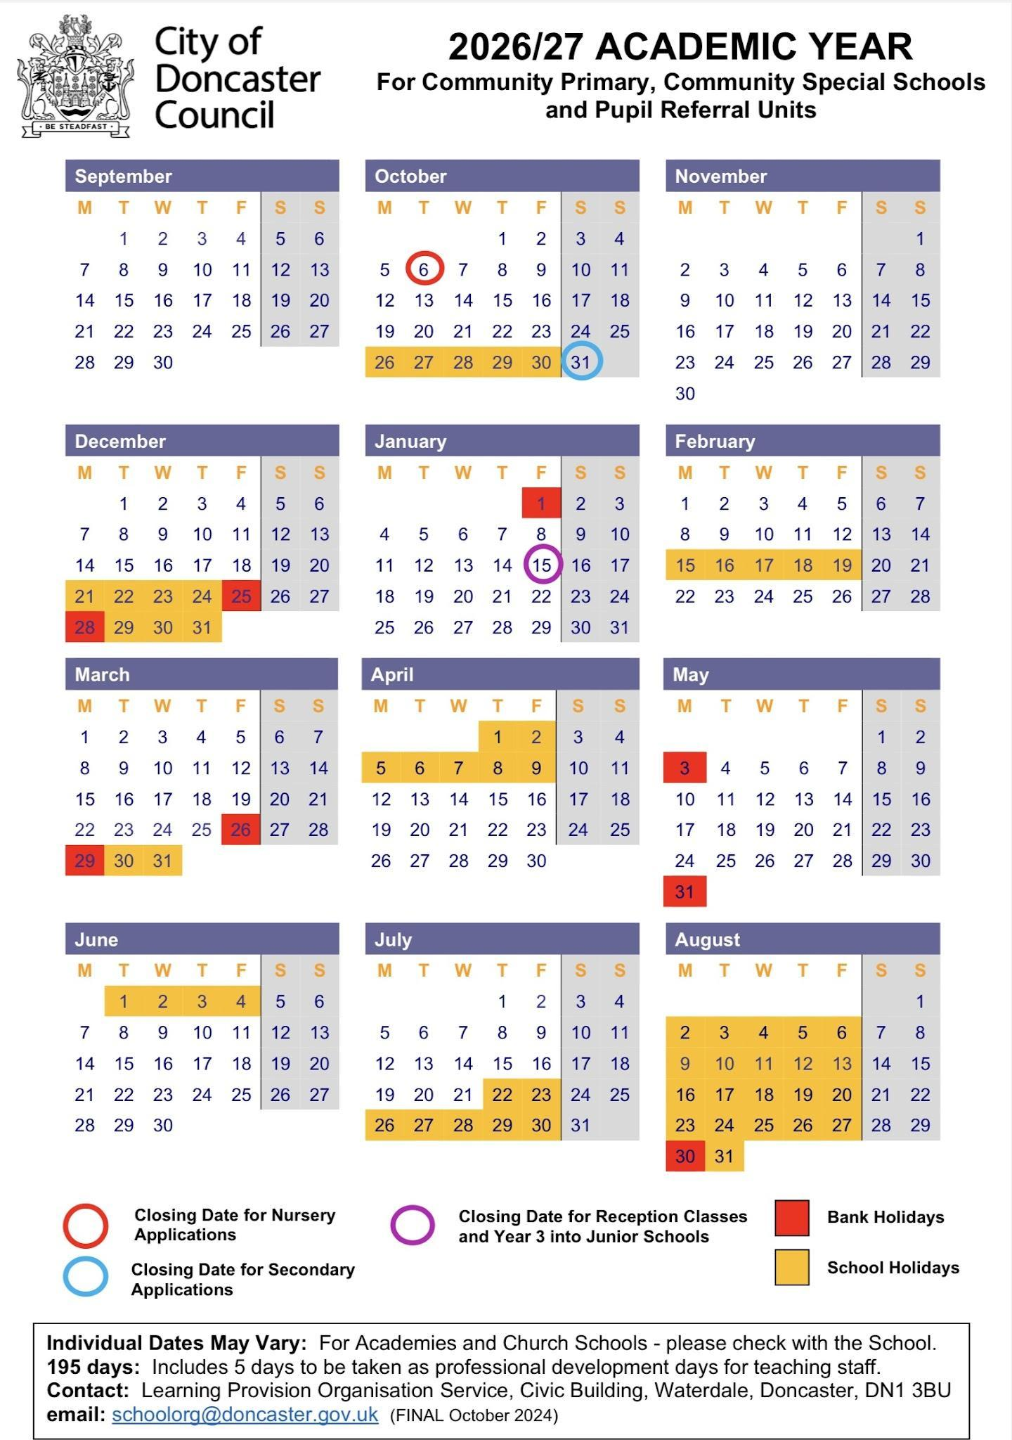
The Academic Year

Inset Days -
Tuesday 1st September 2026
Wednesday 2nd September 2026
Monday 4th January 2027
Monday 12th April 2027
Wednesday 21st July 2027

The School Day
You will be provided with your official timetable on your first day. This schedule will show your daily class times, your subjects, your classrooms, and your scheduled break times.
Example Timetable:

PERIOD | TIME | MONDAY | TUESDAY | WEDNESDAY | THURSDAY | FRIDAY
Check in | 09:00 - 09:15 | Maple Rm Summer | Maple Rm Summer | Maple Rm Summer | Maple Rm Summer | Maple Rm Summer
P1 | 09:15 - 10:15 | ENGLISH inc HWRTNG LISA | ENGLISH inc HWRTNG LISA | ENGLISH inc HWRTNG LISA | SWIMMING / PE | ICT MOLLY inc TEND
 | Room | Elm Rm - Linzi | Elm Rm - Beth | Elm Rm - Linzi | Leisure Centre / Outdoor | Maple Rm
P2 | 10:15 - 11:15 | MATHS MEL | MATHS SUMMER | MATHS SUMMER | SWIMMING / PE | ENGLISH LISA
 | Room | Maple Rm - Linzi | Maple Rm - Beth | Maple Rm - Linzi | Leisure Centre / Outdoor | Elm Rm
BREAK | 11:15-11:30 | LISA & LINZI | LISA & BETH | LISA & LINZI | LISA & SUMMER | LISA & LINZI
P3 | 11:30 - 12:30 | SCIENCE SUMMER | GROWTH SUMMER | GROWTH LISA | MATHS MEL | CCC SUMMER
 |  | Maple Rm - Linzi | Maple Rm - Beth | Elm Rm - Linzi | Maple Rm - Linzi | Maple Rm - Linzi
LUNCH & ENRICH | 12:30 - 1:30 |  | MAPLE
P4 | 1:30 - 2:15 | HUMANITIES SUMMER | CREATIVE / DT LISA | SCIENCE SUMMER | ENGLISH LISA | CREATIVE / DT SUMMER
 | Room | Maple Rm - Linzi | Art Rm - Beth | Maple Rm - Linzi | Elm Rm - Linzi | Maple Rm
Break | 2:15 - 2:30 | SUMMER & LINZI | SUMMER & BETH | SUMMER & LINZI | SUMMER & LINZI | SUMMER & LINZI
P5 | 2:30-3:15 | GUIDED READING & PHONICS MEL | GUIDED READING & PHONICS LISA | GUIDED READING & PHONICS SUMMER | GUIDED READING & PHONICS SUMMER | MATHS MEL
 | Room | Maple Rm - Linzi | Elm Rm - Beth | Maple Rm - Linzi | Maple Rm - Linzi | Maple Rm - Linzi
TEND | 3:15-3:30 | SUMMER Maple Rm | SUMMER Maple Rm | SUMMER Maple Rm | SUMMER Maple Rm | MATHS CONTINUED

You will have three scheduled breaks during the school day to rest and eat. The timings for these breaks are as follows:
Morning Break: 11:15 am - 11:30am (Monday to Friday)
Lunch Break: 12:30 pm – 1:30 pm (Monday to Friday)
Afternoon Break: 2:15 pm- 2:30 pm (Monday to Friday

Our Team - Roles and Responsibilities


Angela Cousins
Proprietor & Headteacher | Designated Safeguarding Lead
Angela is the founder and leader of the school. She is responsible for the school’s overall vision, making sure it is a successful place to learn. As the Designated Safeguarding Lead, her most important job is to ensure that every student is safe and well cared for. Angela’s fun fact is that she is a film director!

Jonathan Cousins
Director of Estates & Infrastructure
Jonathan is in charge of the school buildings and grounds. He makes sure the school is safe, clean, and well-maintained. He also plans for new improvements to the school site to ensure students have the best possible environment. Jonathan’s fun fact is that he went to Germany to compete in Taekwondo!


Naomi Mitchell
Deputy Headteacher | Teaching, Learning & Curriculum Development
Naomi looks after the quality of education at the school. She decides what subjects are taught and how they are taught. She works closely with the teachers to make sure lessons are engaging and that every student is making good progress. Naomi’s fun fact is that she was held hostage by a snake in Australia!

Kate Ludlam
Business & Operations Manager | Pastoral Support and Parent Liaison

Kate manages the "behind-the-scenes" parts of the school. She leads the office and administration teams, handling finances and school operations. She works to ensure the school is organized and has the resources it needs to run smoothly. Kate also supports students and families by helping with communication between home and school. She works closely with parents, carers and staff to make sure students receive the right support. Kate's fun fact is that she is a twin!
Tom Wilson
Assistant Headteacher | Primary & Creative Arts Lead
Tom leads the Primary department and oversees all creative subjects, including music, art, and drama. He is a member of the leadership team who focuses on making sure students have an ambitious and well-rounded education. Tom’s fun fact is that he has jumped out of a plane.

Taylor Cousins
Data & Finance Manager | STEM Educator
Taylor manages the school’s finances and technology. He ensures that the school’s IT systems work effectively for students and staff and handles the data that helps the school track its performance and plan for the future. Taylor also helps lead STEM subjects in secondary school, including Science, Technology, Engineering and Maths. He works to make lessons fun, engaging and challenging, helping students build confidence and achieve their best.
Taylor’s fun fact is that he can spin on his head!

Lewis Kendell
Human Resources & Finance Assistant
Lewis supports the leadership team with the daily running of the school. He assists with staff matters and financial tasks, helping to ensure the school office is professional and helpful for everyone.


Kennedy Cousins
Business Support Officer | Happiness Director
Kennedy supports the day-to-day running of the school, helping everything operate smoothly and efficiently. She works closely with the Business and Operations Manager to support key areas of the school’s organisation. Kennedy is also our Happiness Director. She leads on staff wellbeing, helping to create a positive and supportive working environment. She organises wellbeing initiatives and is someone staff can go to for support, helping ensure the school is a caring place for everyone. Kennedy’s fun fact is that she has lived in New York, USA.


Lisa McGuiness Gibson
Special Educational Needs Coordinator (SENCO) | Elm Teacher (KS3)
Lisa is the person to speak to about extra learning support. She coordinates help for students with special educational needs (SEND), manages Education, Health and Care Plans (EHCPs), and works with parents to make sure every student’s individual needs are met. Lisa is the teacher for Elm class and supports Key Stage 3 students. She creates a calm and supportive classroom where students can build confidence, learn new skills, and make good progress. Lisa adapts lessons to meet different needs so every student feels included and ready to learn. Lisa’s fun fact is that in Year 8 she was the 3rd fastest hurdler in Doncaster!


Summer Scase
Maple Teacher (KS2 & Year 7)
Summer is the teacher for Maple class, supporting Key Stage 2 and Year 7 students. She creates a caring and engaging classroom where students can build confidence in their learning, communication, and social skills. Summer helps students settle into school life, build positive relationships, and learn the routines that support success. Summer’s fun fact is that she has 10 different allergies.


Kerry Thornton
Oak Teacher (KS4) | Gifted and Talented Coordinator
Kerry is the teacher for Oak class, supporting Key Stage 4 students. She plans engaging lessons that help students work towards qualifications and prepare for their future. Kerry supports students to build confidence, independence, and resilience as they get ready for their next steps in education, training, or work. Kerry also supports students who show particular strengths or talents by providing extra challenge and opportunities to help them achieve their best. She works with staff to make sure all students are encouraged to reach their full potential. Kerry’s fun fact is that she lived in both America and Spain!

Melanie Williamson
Teacher
Melanie is a teacher who supports students with a wide range of subjects and learning needs. She plans engaging lessons that are adapted so every student can take part and make progress. Melanie creates a calm and supportive classroom where students feel safe, confident, and ready to learn. She helps students build important skills, independence, and a positive attitude towards learning. Mel’s fun fact is that she used to win cake decorating competitions!

Linzi Dunderdale
Inclusion Manager | Thrive Practitioner | Behaviour & Wellbeing Lead | Student Pastoral Support
Linzi helps make sure the school is a welcoming and supportive place for everyone. She supports students’ wellbeing and behaviour, helping staff understand how to respond in a caring and positive way. Linzi also makes sure that no student is left out because of financial challenges, so everyone can take part fully in school life. She supports staff and is someone students and families can speak to if they have any concerns about wellbeing or inclusion. Linzi also supports students with their wellbeing and day-to-day needs in school. She helps students overcome challenges, feel supported and succeed both personally and academically. Linzi’s fun fact is that she has climbed Mount Machu Picchu in Peru!

Chloe Perry
Academic Intervention Coach


Chloe helps students who need extra support with literacy, phonics and maths. She works with individuals or small groups, using structured programmes such as Fresh Start and Read Write Inc to build their skills and confidence. Chloe supports students to overcome challenges in their learning so they can take part fully in lessons and make good progress. Chloe’s fun fact is that she can flip her eyelids inside out!

Chloe Marshall Bethany Hicks
Learning Coach Learning Coach



Lewis Russell Molly Clegg-McGuinness
Learning Coach | TEDxYouth Ambassador Learning Coach | Handwriting Champion
Chloe, Beth, Lewis and Molly support students with their personal development, confidence, and readiness to learn. They help students build positive learning habits, follow routines, and feel successful in school. They provide guidance, encouragement, and support to help students overcome challenges that may affect their learning or wellbeing. Chloe, Lewis and Molly help students develop resilience, motivation, and independence so they can reach their full potential. Chloe’s fun fact is that she collects penguins! Beth’s fun fact is that she has been abroad to watch Formula 1!
Lewis encourages students to share their ideas, use their voice and develop confidence in speaking and presenting. He supports opportunities that promote creativity, leadership and communication skills. Lewis’s fun fact is that he makes music!
Molly helps students to develop clear, neat and confident handwriting. She supports staff and pupils with ideas and strategies to improve handwriting across the school. Molly’s fun fact is that her record for kick-ups is 248!

The National Curriculum

The National Curriculum provides pupils with an introduction to the essential knowledge that they need to be educated citizens. It also helps engender an appreciation of human creativity and achievement. Journey strives to ensure support pupils to become:
- Successful learners who enjoy learning, make progress and achieve
- Confident individuals who are able to live safe, healthy and fulfilling lives
- Responsible citizens who make a positive contribution to society.
The National Curriculum is just one element in the education of every child. There is time and space in the placement each week to range beyond the National Curriculum specifications. Journey prides itself on the ability to stretch and challenge learners to take them beyond their own barriers and expectations. The National Curriculum provides an outline of core knowledge around which teachers can develop exciting and stimulating lessons to promote the development of pupils’ knowledge, understanding and skills. This is part of a wider curriculum that we use to help grow the learner as a whole person.
Phonics
At Journey, we follow the ‘Read Write Inc’ phonics programme, created by Ruth Miskin. It is a comprehensive literacy program designed to help students develop strong reading and writing skills.
What is Read Write Inc (RWI)?
Read Write Inc is a systematic and phonics-based approach to teaching reading, writing, and spelling. It is built on the following key principles:
- Phonics Focus: RWI places a strong emphasis on phonics, teaching children to decode words by understanding the relationship between sounds (phonemes) and letters (graphemes).

- Structured Learning: The program is structured into well-defined stages, ensuring a gradual and sequential progression in reading and writing skills.

- Assessment and Differentiation: RWI includes regular assessments to monitor each student's progress and tailor instruction to their needs, ensuring that no child is left behind.
How is Read Write Inc Delivered?
RWI is delivered through a structured and consistent approach that ensures all students receive high-quality instruction. Here's how it is typically delivered:
- Grouping: Students are grouped according to their reading level and progress, allowing teachers to provide targeted instruction to meet individual needs.

- Daily Lessons: RWI lessons are typically delivered daily, providing consistent exposure to phonics, reading, and writing activities.

- Phonics Sessions: These sessions focus on teaching phonemes, graphemes, and blending skills to help students decode words effectively.

- Reading Sessions: Students engage in guided and independent reading, using books specifically designed to match their current reading level.

- Writing Sessions: Writing activities complement the reading curriculum, allowing students to apply their knowledge of phonics to spelling and writing.

- Assessment and Tracking: Regular assessments and progress tracking ensure that teachers can adjust instruction to meet the needs of each student.
Read Write Inc is a research-based and effective literacy program that focuses on phonics, structured learning, and individualised instruction. By following the principles outlined in this handbook, students can develop strong reading and writing skills, setting them up for success in their academic journey.

Reading
Reading is an exciting adventure that opens doors to magical worlds and endless possibilities. In this handbook, we'll explore the wonderful journey of reading, both at school and at home. Let's dive in!
Why Reading Matters:
Reading is not just about words on pages; it's about unlocking your imagination, expanding your knowledge, and becoming a confident and skillful reader. The more you read, the more you learn!
Reading at Journey:
During your time at Journey, you will have the fantastic opportunity to read with our dedicated adults in our special reading provision. This is a chance to explore books, ask questions, and share stories together. We have hundreds of books in the hub, so there will definitely be something that you can find and enjoy!
Reading at Home:
But the reading adventure doesn't end with Journey. We encourage you to read at home too. Reading at home is like adding extra chapters to your reading journey. Here's how it works:
- Minimum Reading Goal: We recommend reading at least three times a week at home. You can read to a family member, a friend, or even to yourself!
- Record Your Reading: Use your reading planner to keep track of your reading adventures. For each time you read at home, jot it down in your planner. This helps you remember your progress.
- Reward Tracker: Every read at home gets you closer to exciting rewards! We have a special reward tracker just for you. Every ten reads earn you a prize. But guess what? When you reach 50 reads, you unlock a fantastic, extra-special reward!
Tips for Reading Success:
- Choose Books You Love: Pick books that interest you. Whether it's about space, dinosaurs, or adventures in far-off lands, reading should be fun!
- Read Aloud: Reading aloud is a great way to practice your reading skills and share stories with others.
- Ask Questions: If you're not sure about a word or what's happening in the story, don't be afraid to ask questions. That's how you learn and grow as a reader.
- Explore Different Genres: Try reading different types of books – from fiction and fantasy to nonfiction and comics. You might discover new favourites!
Reading is a fantastic journey, and we're here to support you every step of the way. Reading in the hub and at home, recording your progress, and aiming for those exciting rewards will help you become a superstar reader! So, grab a book, start reading, and let your imagination soar! Happy reading!

Growth / PSHE
At Journey, the Growth and PSHE programme follows the RSE curriculum. It teaches students about emotions, relationships, personal identity, health, and wellbeing. Students also take part in weekly Muse or Oak lessons, which cover Health and Wellbeing, Understanding Relationships, and The World Around Us. Growth lessons are tailored to each class and can be personalised to meet individual students’ needs, ensuring all learners are supported at the right level.
Staff support students in understanding and managing their emotions using strategies like co-regulation and the “Zones of Regulation.” This helps students recognise their feelings, understand how emotions affect their behaviour and learning, and respond better in challenging situations.The Hidden Chimp programme helps students learn how the brain works and why they react emotionally. It teaches them to identify triggers and develop their own ways to manage emotions effectively.
Overall, this focus helps students build emotional awareness, self-control, and confidence. It supports both their learning and personal development, preparing them for life in and beyond school.
TEND
Every afternoon at Journey, the day ends with 15 minutes called TEND. It's not a normal lesson — nothing in it is marked, graded, or assessed. TEND is about you as a whole person, not just as a student. It belongs to you. Each day of the week has its own focus: Monday is about you (SELF), Tuesday is about the natural world (EARTH), Wednesday is about the people around you (COMMUNITY), Thursday is about the wider world (WORLD), and Friday is about curiosity, creativity, and the arts (WONDER). You'll use different art forms throughout the year — photography, poetry, music, drama, writing, drawing, film, dance, and the school garden — as ways of thinking and expressing yourself. You don't need to be good at any of them. You just need to show up.
Every session ends exactly the same way. Your teacher will ask three questions out loud: What did I notice? What do I care about? What will I tend? You don't have to answer them. But they're worth sitting with. TEND runs for exactly 15 minutes, starts on time, and ends on time — every single day. Nothing you make in TEND will be shared or displayed without your permission.

Swimming
To ensure every child gains essential life skills, swimming is a mandatory part of our PE curriculum, for at least one term each year. We prioritise this to help students build confidence in the water, improve their cognitive function, and stay physically active.
Bullying
We have zero tolerance for bullying at Journey.
What are the signs and symptoms of bullying? A person may indicate by signs or behaviour that they are being bullied.
Everyone should be aware of these possible signs and should investigate if the person:
– is frightened of walking to or from school or changes route
– doesn’t want to go on public transport to school
– begs to be driven to school
– changes their usual routine
– begins to truant
– becomes withdrawn, anxious, or lacking in confidence
– becomes aggressive, disruptive or unreasonable
– starts stammering
– threatens or attempts suicide
– threatens or attempts to run away
– feels ill in the morning
– asks for money or starts stealing money
– has unexplained cuts or bruises
– is frightened to say what’s wrong
– is afraid to use the internet or mobile phone
– is nervous and jumpy when a cyber message is received
Reporting bullying at Journey
You should report bullying immediately if it happens to you or a friend.
How to report bullying
– complete a statement which you can put in the anonymous ideas box
– Tell a member of staff

What should I do if...
I’m running late? | Ask your parent/carer to let us know by calling 01302 492239
I am being bullied. | Tell someone – your tutor, a parent, a teacher or a friend.
I have a dental/medical appointment? | Ask your parent/carer to let us know by calling 01302 492239
I lost something? | Lost property is kept in the office.  Please leave valuables at home where possible.
I don’t understand a home learning task? | See your subject teacher for help.
I have forgotten to bring something to school? | Explain to your subject teacher at the start of the lesson.
I got something confiscated? | Items will be returned at the end of the learning day.
I don’t feel well? | Tell your teacher.
I am absent | Get a parent/carer to phone us on 01302796090
I take medication? | Leave all medication at the office. Ask your parent/carer to inform the office and complete a medication form.

Journey Calendar:
Whole School Trip W/C 19th October
Whole School Trip W/C 14th December
Whole School Trip W/C 8th February
Whole School Trip W/C 22rd March
Whole School Trip W/C 24th May
Whole School Trip W/C 12th July
Whole School Sports Day W/C 19th July
Careers Day - Dates subject to availability.

Reports and Parents Evening Dates

Term 1 - Autumn
- Tuesday 13th October – Pastoral Parents Evening
- Monday 11th January – Progress Report
- Tuesday 12th January - Parents Evening
Term 2 - Spring

- Monday 19th April – Progress Report
- Tuesday 20th April - Parents Evening
Term 3 - Summer
- Tuesday 13th July - Parents Evening
- Monday 19th July – End of Year Reports

Student Voice
Student Voice is a huge part of life at Journey Independent School. Students have their own input into decision making at JEG. We want you to explore other positions of responsibility. The skills students get from taking part in Student Voice are important for getting into college, sixth form and University. They show your dedication to your education and development.

Student Postboxes
We have postboxes located in the entrance hallway where students can share anything they would like us to know. This may include how they are feeling, ideas or suggestions, praise postcards, or any worries and safeguarding concerns. Students may choose to include their name or remain anonymous if they prefer. These postboxes are checked regularly so that we can listen to student voice and provide support where needed.



Uniform Policy
At Journey, we do not have a uniform policy and encourage students to wear clothing that makes them feel comfortable and confident, as we believe this supports their focus and learning. However, we ask that students refrain from wearing pyjamas, as they are not suitable for a school environment. Additionally, we do not permit balaclavas for safety purposes. Regarding jewellery, we allow small studs and watches, but we ask that students leave valuable items at home to minimize the risk of loss or theft. Our goal is to create an environment where students can be relaxed and focused on their education.
Healthy Eating
At Journey Independent School we provide a free, healthy hot lunch every day on a 2 week rolling menu to any student in receipt of Free School Meals (FSM). A copy of this can be provided on request, if you would like a copy of this please email admin@journeyeducationgroup.co.uk
For any student not in receipt of FSM, we ask that parents or carers provide an appropriate packed lunch for their child. As we continue to support the growth and development of our students at Journey Independent School, we ask that packed lunches are nutritious and in accordance with the NHS Eatwell Plate guidelines.
https://www.nhs.uk/live-well/eat-well/food-guidelines-and-food-labels/the-eatwell-guide/
A balanced diet is essential for our children's physical and mental well-being. It provides them with the energy and nutrients they need to focus, learn, and thrive throughout the day.
Additionally, fizzy, energy, and isotonic drinks are not permitted at Journey Independent School. We believe that providing our students with healthy choices contributes positively to their overall school experience.
Clothing, Food and Hygiene Bank
Our school Clothing, Food and Hygiene Bank is here to support students and families who may need extra help. It provides access to clothing, food and essential hygiene items in a respectful and confidential way. If you or your family would benefit from this support, please speak to a member of staff who can help you access it. We also welcome donations from those who are able to give, including clean clothing, non-perishable food and unopened hygiene products, helping us care for one another as a school community.
Educational Visits and Rewards Trips
Students at Journey Independent School will have the opportunity to attend one trip every half term, free of charge. Each term will include one rewards-based trip and one academic trip to support learning and positive experiences outside the classroom.
Attendance on trips is a privilege and will be based on each student’s work, attitude, and behaviour in the Independent School. Students are expected to follow school expectations, engage positively in learning, and show respect to staff, peers, and the school environment.
Students who consistently demonstrate positive behaviour, effort, and engagement in their learning are more likely to be offered places on trips.
Journey Independent School uses trips to recognise achievement, support learning, and promote positive social experiences.
Furthering Learning
Homework helps students to practise skills and continue learning outside of the classroom. It supports progress, independence, and readiness for future learning.
Students are expected to complete one English and one Maths homework task each week.
Homework will be set on each student’s personal Seesaw account. Login details will be provided during induction. Students will need access to a mobile device, tablet, or computer to view instructions and complete their tasks.
Students who complete their homework will receive rewards and recognition for their effort.
If a student is unable to access or complete their homework, they should inform a member of staff so support can be provided.
Students within the provision have further opportunities to take part in swimming lessons and music lessons, delivered by professional tutors. These activities are designed to build confidence, develop new skills, and provide enriching experiences that may not always have been available to our cohort of students in the past.
Journey Education Tutoring Scholarship
Students at the Independent School may also have access to scholarship-funded private tuition through Journey Education Tutoring, free of charge. A range of subjects and lesson options are available to support learning, strengthen academic skills, and build confidence.
Further information about additional tuition can be found on our timetables below or obtained from the school administration team.
The Independent School is committed to providing meaningful opportunities that support personal development, engagement, and success both in and beyond the classroom.
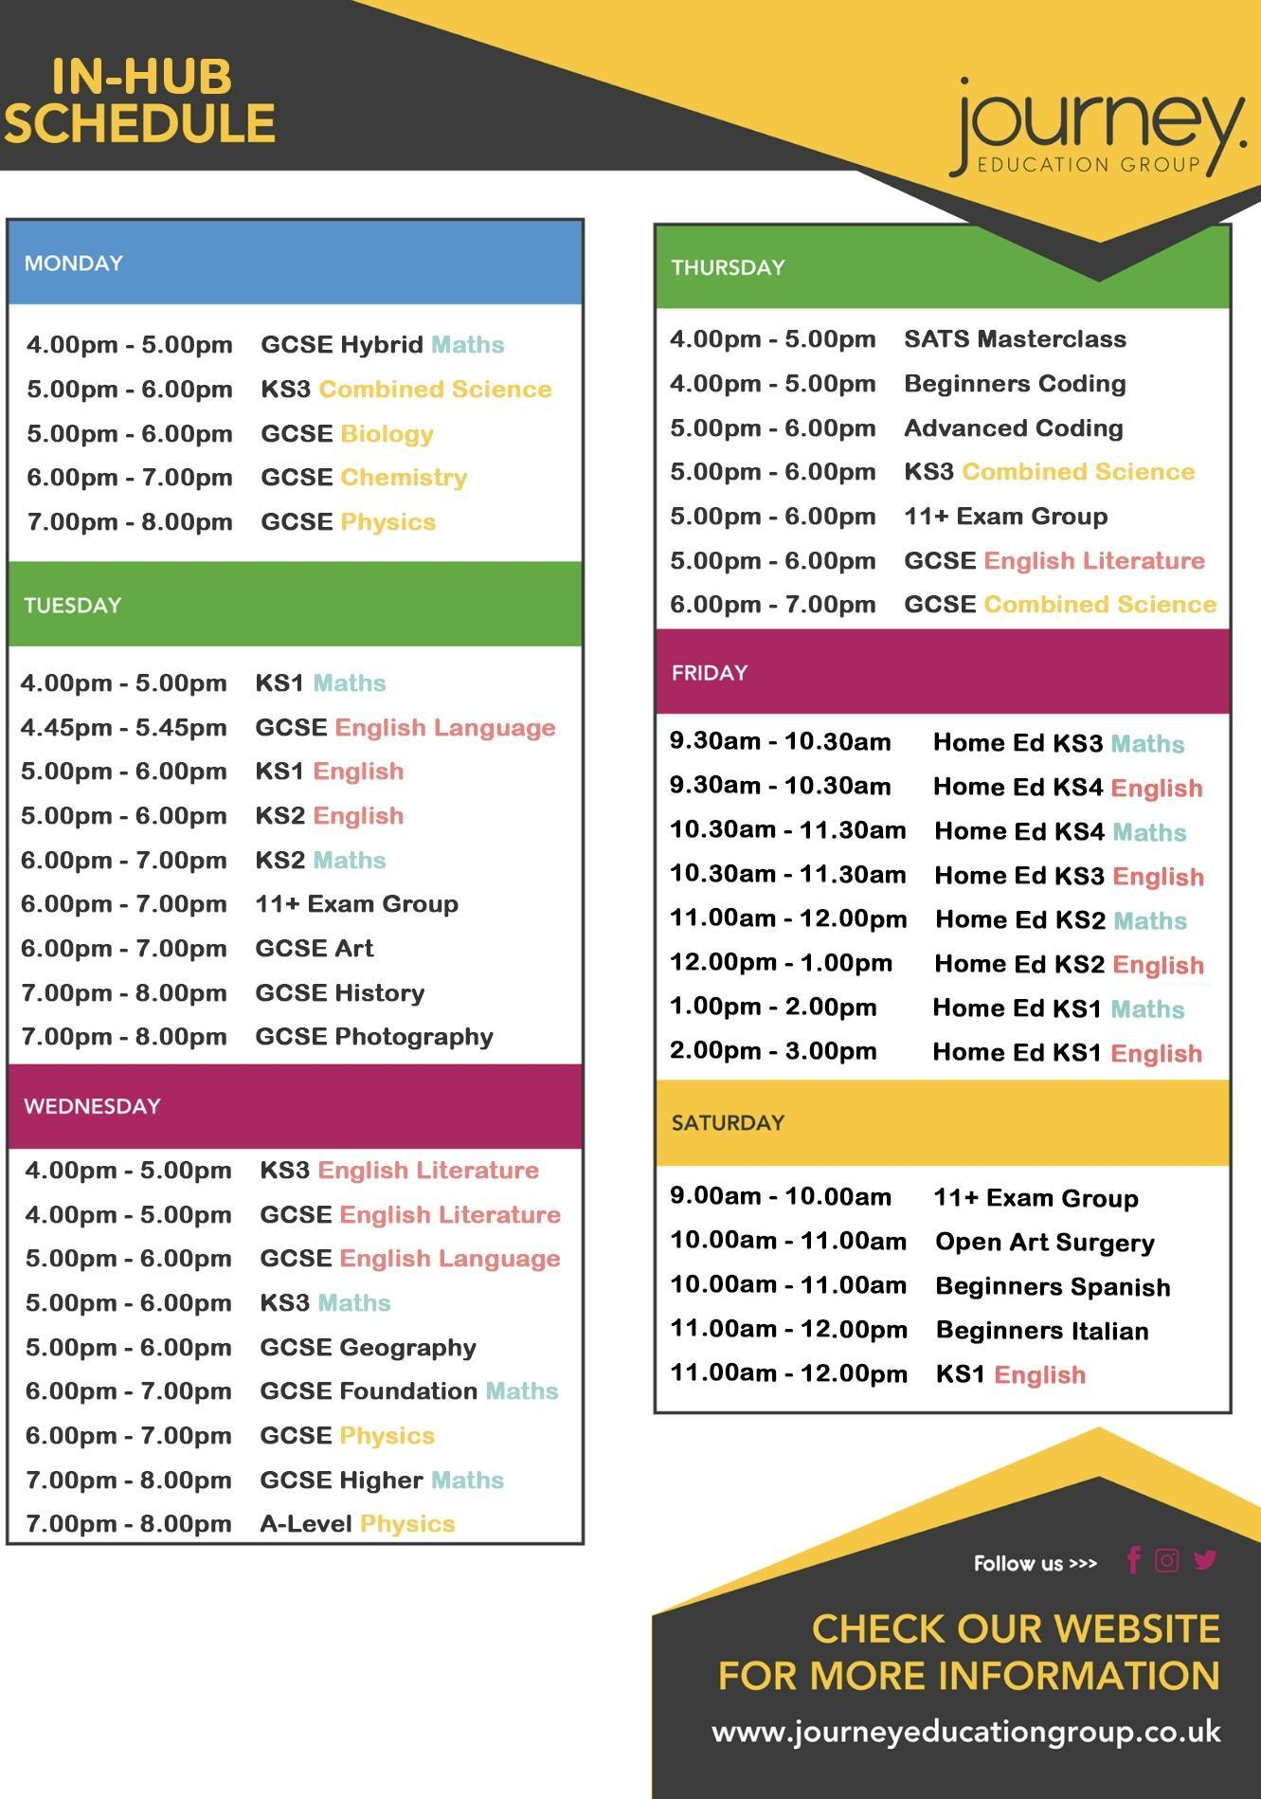
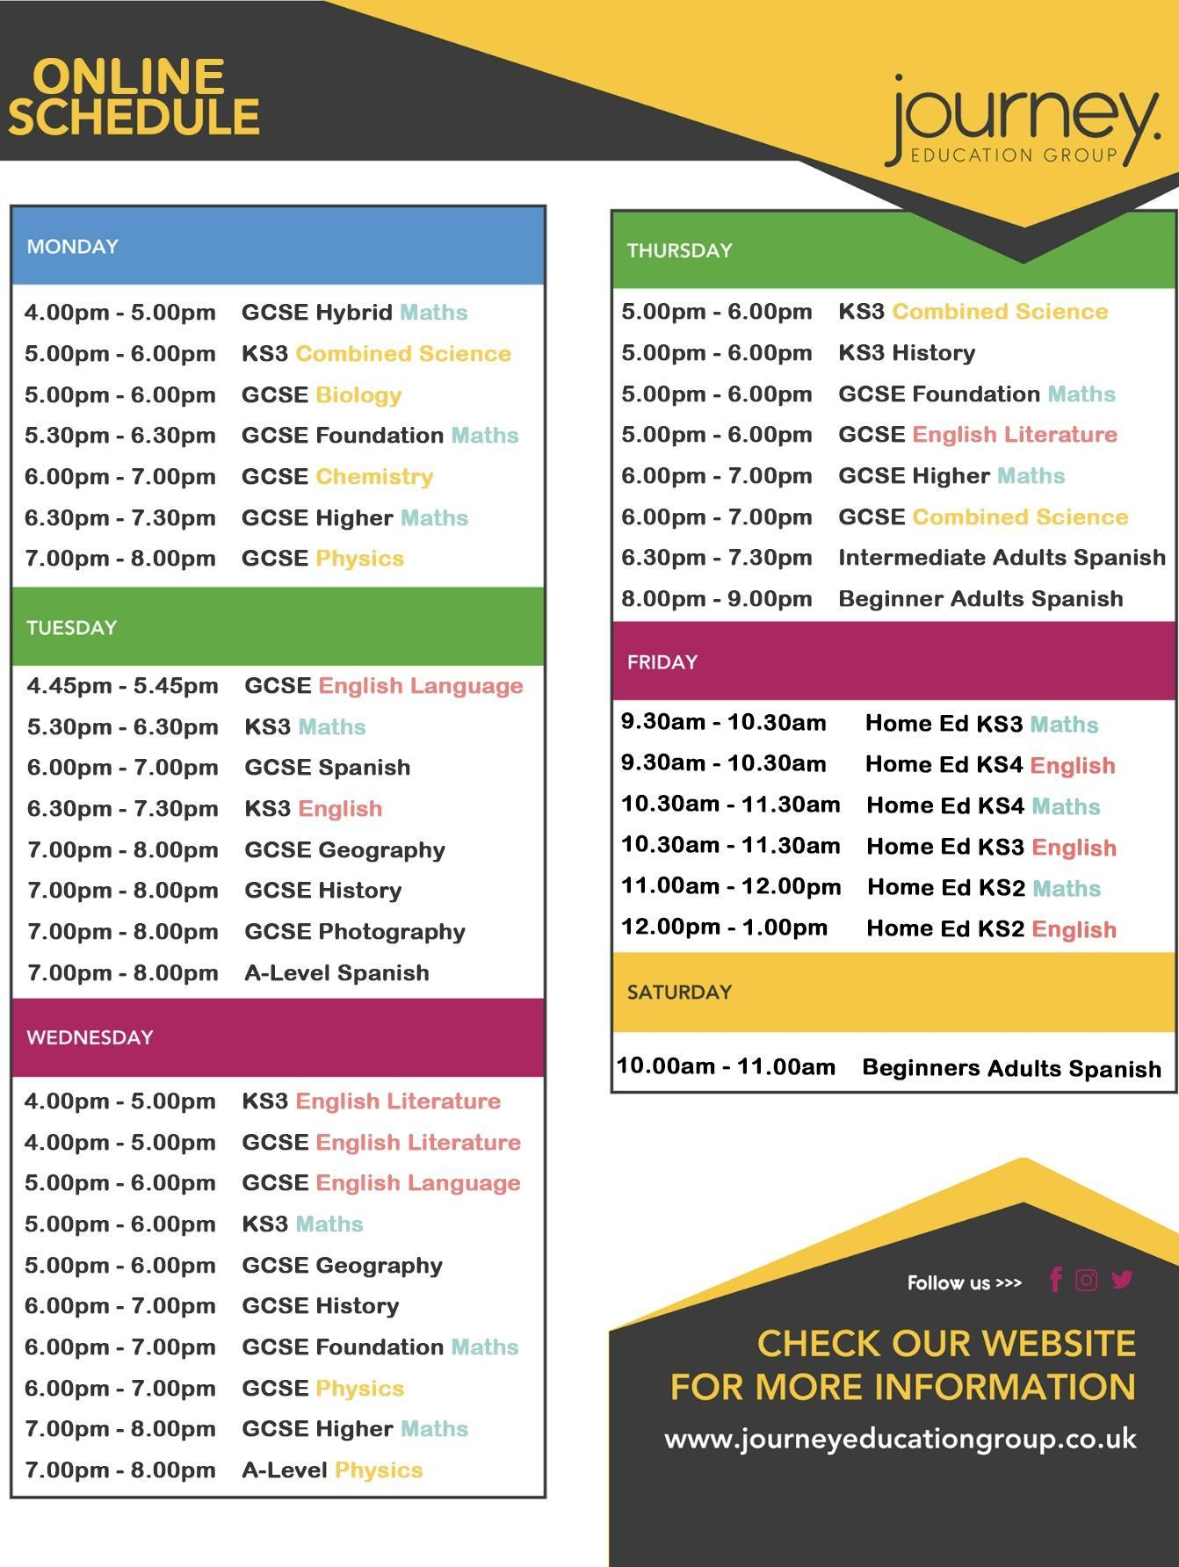

Safeguarding Information
At Journey, we are committed to the safety and happiness of our students.
Are you feeling unwell or unsafe?
Are you worried about a friend, student or family member?
Does something not feel right?
Share your concerns with us in our safeguarding postbox or
Please speak to the
Journey Independent Child Safeguarding Leads
Tel: 01302 492239
Email: safeguarding@journeyeducationgroup.co.uk

Angela or Naomi
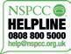
For advice if you’re not in school, ring the NSPCC: 0808 800 5000
or Childline: 0800 1111


If you’re worried, tell someone.
In an emergency dial 999

Navigating ADHD: Your Strengths, Your Success
Living with ADHD (Attention Deficit Hyperactivity Disorder) might sometimes feel like a challenge, but it's crucial to recognize that you possess unique strengths and qualities that can empower you to excel. Here are some tips to help you thrive:

1. Embrace Your Uniqueness:
Remember, having ADHD doesn’t define your worth or potential. Embrace your individuality, creativity, and unique way of thinking. Many successful people have ADHD and have turned their differences into strengths.

2. Understand Your Challenges:
Learn about ADHD—understanding your challenges is the first step in overcoming them. Talk to your healthcare provider, read books, or join online communities where you can connect with others who share similar experiences.

3. Develop Strategies:
Work with your teachers, parents, and counsellors to create personalised strategies that help you stay focused and organised. Simple tools like planners, reminders, and breaking tasks into smaller steps can make a significant difference.

4. Advocate for Yourself:
Don't be afraid to advocate for your needs. Let your teachers and peers know what support you require to succeed academically and socially. Communication is key.

5. Use Your Energy Wisely:
Channel your energy into activities you’re passionate about. Sports, arts, or any hobby can be an excellent outlet for your energy and a way to build self-confidence.

6. Practice Self-Compassion:
Be kind to yourself. Don’t compare your progress with others. Acknowledge your efforts and achievements, no matter how small they may seem. You are doing your best, and that's enough.

7. Break Tasks into Smaller Steps:
When faced with overwhelming tasks, break them down into smaller, manageable steps. Tackling one part at a time can make even the most daunting task feel achievable.

8. Build Supportive Relationships:
Surround yourself with friends and family who understand and support you. Healthy relationships are essential for emotional well-being.

9. Learn Stress Management Techniques:
Practice relaxation techniques such as deep breathing, meditation, or yoga. Managing stress can help you focus and maintain a positive outlook.

10. Stay Organised:
Use tools like calendars, reminders, and apps to stay organised. Creating routines and sticking to schedules can help you manage your time effectively.

11. Believe in Your Potential:
Believe in yourself. You have unique strengths, creativity, and resilience. With determination and the right support, you can achieve your goals and dreams.

Be Smart, Stay Safe: Your Guide to Responsible Social Media Use

1. Think Before You Post:
- Respect Privacy: Don’t share personal information like your address or phone number.
- Be Mindful: Consider how your posts may be interpreted and if they could be hurtful or offensive to others.

2. Inappropriate Images:
- Think Twice: Never share explicit, inappropriate, or compromising photos of yourself or others.
- Respect Boundaries: Don’t pressure others to share such images, and report anyone who does.

3. Online Respect:
- Be Kind: Treat others online as you would in person. Avoid cyberbullying and respect different opinions.
- Think Empathy: Remember, there’s a real person behind every screen.

4. Legal Information:
- Age Restrictions: Many social media platforms have age limits; make sure you meet the minimum age requirements.
- Copyright: Don’t use someone else’s work without permission, including images, videos, or music.
- Consequences: Sharing inappropriate images, cyberbullying, or harassment can lead to serious legal consequences.

5. Security Measures:
- Privacy Settings: Understand and use privacy settings to control who can see your posts and information.
- Strong Passwords: Use strong, unique passwords for each of your accounts to prevent hacking.
- Two-Factor Authentication: Enable this feature for an extra layer of security.

6. Mental Health Matters:
- Limit Screen Time: Balance your online and offline life. Excessive social media use can affect mental well-being.
- Reach Out: If you’re feeling upset or threatened, talk to a trusted adult, teacher, or a helpline like Childline.

7. Reporting and Blocking:
- Report Abuse: Report any form of harassment, bullying, or inappropriate content to the platform and, if necessary, to the police.
- Block Harmful Users: Don’t hesitate to block individuals who make you uncomfortable or engage in negative behaviour.

8. Stay Informed:
- Updates: Be aware of changes in social media platforms’ terms of service and privacy policies.
- Awareness: Stay informed about online trends, scams, and potential risks.

Remember: Your Online Presence is Permanent!
- Think Long-Term: What you post now can affect your future opportunities, friendships, and relationships.
- Digital Footprint: Your online activities leave a trace; ensure it’s a positive one.
Stay Safe, Stay Smart!
For more information and support, visit UK Safer Internet Centre: www.saferinternet.org.uk

R.E.S.P.E.C.T. in the Classroom:
R - Responsibility:
- Complete assignments on time.
- Bring necessary materials to class.
- Respect others' belongings and school property.
E - Engage:
- Actively participate in class discussions.
- Listen attentively when others are speaking.
- Be open to new ideas and perspectives.
S - Support:
- Help classmates in need.
- Encourage and uplift each other.
- Respect diverse opinions and backgrounds.
P - Punctuality:
- Be on time for every class.
- Respect others' time; avoid disruptions.
- Manage your time wisely to meet deadlines.
E - Empathy:
- Understand and share others' feelings.
- Be kind and considerate to classmates.
- Walk in others' shoes; be compassionate.
C - Courtesy:
- Use polite language and manners.
- Respect personal space and boundaries.
- Wait your turn; be patient and respectful.
T - Tolerance:
- Accept and appreciate differences.
- Avoid prejudice and discrimination.
- Celebrate diversity within the classroom.
Growth Mindset at Journey
- Embrace challenges, they fuel your growth.
- Learn from failures; they're stepping stones.
- Effort leads to improvement; never give up.
- Embrace criticism; it's a chance to learn.
- Believe in your ability to grow and succeed!

Journey Independent School
Published by Journey Independent School © 2025. All rights reserved.
Author | Angela Cousins | Journey Independent School Managing Director



