Journey Post 16 Provision
Student Handbook
September 2026



Contents
Contents

Contents
Congratulations
Agreement
Academic Year
Alternative Provision: The Secondary Day
Our Team
The National Curriculum
Bullying
What should I do if...?
Student Voice
Safeguarding Information
Furthering Learning
Maths Formulae
Navigating ADHD
Apps that Support Learning
Responsible Social Media Use
R.E.S.P.E.C.T in the Classroom
Meet the Teachers

Welcome to Journey Alternative Provision
There are schools, and then there is Journey.
You are here because you are not like every other student — and that is not a problem. That is the whole point. A lot of young people who come to us have spent time in places that didn't really get them. Places where they felt too much, or not enough, or just different. What those places missed is what we see immediately: you are incredible. Genuinely, specifically, uncommonly incredible — and you deserve a school that knows that from day one. If you've ever doubted it, that stops here.
At Journey, we will never ask you to shrink yourself to fit. We will ask you to grow. And we will be right there with you when you do.
We believe — and we mean this — that every single student who walks through our doors has something brilliant in them. A talent, a strength, a way of seeing the world that is entirely their own. Finding that thing, and building on it, is what we are here for. Your learning journey here is built around you — not a template, not a test score, not what someone else decided you were capable of.
We are also a family.
That means the people here — your teachers, your support staff, your fellow students — look out for each other. You will be known here. Not as a file or a set of needs, but as a person. And you will be expected to bring that same respect to everyone around you too.
We are lucky enough to be based in one of the most extraordinary buildings in Doncaster — a Grade I listed building with over nine hundred years of history that once belonged to the Crown. We have forest and land that we are turning into something living and wild. You will learn in those spaces. You will help shape them. That is not something many young people get to say.
We care about the world here, not just the classroom. We are working hard to be a school that does things the right way — for people, for communities, for the planet. You are part of that.
This is your handbook. It will tell you how things work, what to expect, and what is expected of you. But more than anything, it is a reminder of what you have just become part of.
Something genuinely different. Something worth being proud of.
Welcome. We are glad you're here.
Angela Cousins
CEO, Founder and Executive Headteacher
Angela Cousins
Home/Journey Agreement
Our Aims
- To generate an enthusiasm for learning amongst the students, so that they willingly seek to gain knowledge and understanding about the world around them.
- To provide students with the guidance, information and resources necessary to help them learn and make progress.
- To teach students the skills necessary for effective and efficient learning.
- To provide students with a positive learning environment.
- To develop a sense of pride amongst the students, so that they always aim to achieve the highest possible standards of work in all subjects.
- To foster the personal qualities, skills and self-confidence necessary for success in their chosen career and personal life.
- To develop amongst all students a sense of respect for themselves, other individuals, their own communities as well as others, plus their environment.
As a provision we undertake to:
- Provide a secure, welcoming and high quality learning environment.
- Care for each student’s emotional health and wellbeing.
- Deliver a bespoke curriculum and provide a personalised education which aims to meet the individual needs of each post 16 student.
- Ensure that appropriate home learning is set, marked and monitored.
- Report regularly to parents and provide opportunities to discuss students’ progress.
- To support parents/carers through the period of their child’s transition to Journey Post 16 Provision.
- Contact parents/carers if there are concerns about attendance, punctuality, behaviour or progress.
- Respond sensitively and promptly to any concern or complaint raised by a parent/carer or student.
- Provide information and guidance about careers and higher education.
- Acknowledge, celebrate and reward students’ success and progress in all its forms.
- Create opportunities to enrich and enhance student experiences .
Signed (Journey Post 16 Provision)
As a Student of Journey, I undertake to:
- Attend school punctually and with minimum absence.
- Dress appropriately for a college day.
- Bring necessary equipment and books.
- Complete college work and home learning as well as I can.
- Ask teachers for help when I have problems with my work and not give up when work is hard.
- Behave responsibly and considerately at all times both in Journey and in the wider community - including returning punctually after independent break and lunch times.
- Conduct myself in such a way as to enhance Journey’s reputation.
- React positively to a teacher’s reasonable instructions.
- Seek help from the Journey team if I have a concern or need help or guidance.
- Listen to and act upon advice to develop my academic progress and all other areas of Journey life.
- Observe Journey’s rules and Code of Conduct – this includes surrendering phones until lunch time and returning them after lunch, and no vaping/smoking - our site is an NHS No Smoking site and these are prohibited on site and below the age of 18.
- Engage with any Enrichment Programmes offered by Journey to widen my experiences in life.
Signed (Student)
As Parents and Carers we undertake to:
- To support the aims and ethos of the school while encouraging my/our child
- Ensure that my/our child attends school punctually and with minimum absence.
- Ensure that my/our child is appropriately dressed for the college day.
- Ensure that my/our child completes all home learning set to the best of his/her ability and in reasonable working conditions.
- Attend Parents’ Consultation Evenings and meetings about my/our child’s progress.
- Support my/our child to achieve learning and progress targets by being active learners.
- Not take my/our child out of college during term time without the explicit permission of the centre manager.
- Encourage my/our child to participate in extracurricular activities.
- Recognise and support the rewards and sanction procedures of the school.
- Advise the school of any concerns or problems which might affect my/our child’s progress.
- Work constructively and cooperatively in partnership with the school to resolve any concerns about attendance, punctuality, behaviour or work.

Signed (Parent/Carer)

The Academic Year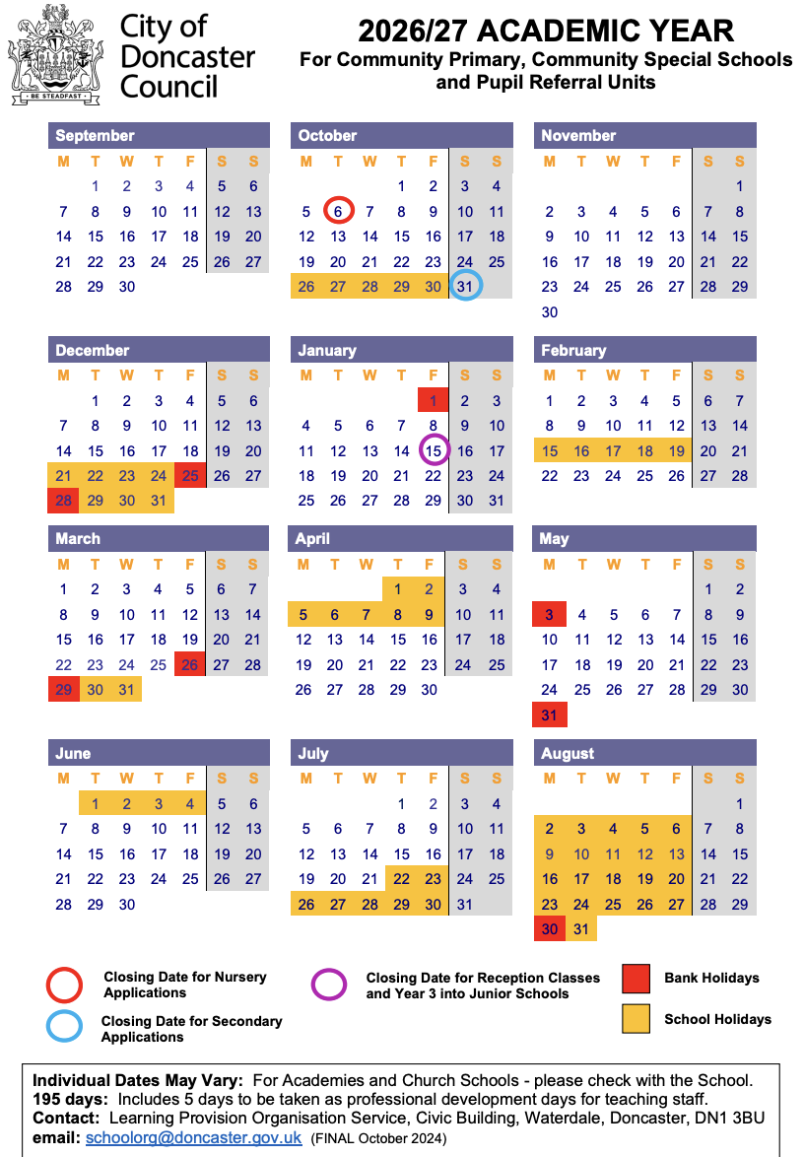

Inset Days:
Tuesday 1st September 2026
Wednesday 2nd September 2026

The Post 16 DAY
PERIOD | TIME | MONDAY | THURSDAY | FRIDAY
Check in | 09:00 - 09:15 | St Cath’s House | St Cath’s House | St Cath’s House
P1 | 09:15 - 10:05 | MATHS | PERSONALISED PATH | MATHS
P2 | 10:15 - 11:15 | ENGLISH | ENGLISH | ENGLISH
BREAK | 11:15-11:30
P3 | 11:30 - 12:30 | PERSONALISED PATH | PERSONALISED PATH | PERSONALISED PATH
LUNCH | 12:30 – 1:30
P4 | 1:30 - 2:15 | GROWTH | MATHS | PERSONALISED PATH
Break | 2:15 - 2:30
P5 | 2:30-3:15 | PERSONALISED PATH | GROWTH | LIFE / CAREERS
TEND | 3:15-3:30 | Log Cabin | St Cath’s House | Legacy Hub
The Post 16 day is designed to provide students with structure, consistency, and personalised support in a nurturing environment. Students begin the day with a calm arrival and check-in session, allowing staff to support wellbeing, discuss any concerns, and help students prepare positively for learning. During this time, students also set individual targets for the day, encouraging reflection, motivation, and personal responsibility.
Throughout the morning, students take part in core subjects including English, Maths, and resit sessions. These smaller-group lessons are delivered by specialist staff and are tailored to meet individual needs, helping students build confidence, develop key skills, and experience success within a supportive setting.
In the afternoon, the focus shifts towards their personalised pathway, Growth programme and therapeutic and vocational-style learning opportunities. Students engage in subjects agreed for their bespoke learning pathways alongside Careers, Growth and Life [preparation for adulthood]. These sessions are designed to promote self-expression, teamwork, resilience, and emotional development while allowing students to explore interests and develop wider life skills in a positive and engaging way.

Staff Roles and Responsibilities


Angela Cousins
CEO & Headteacher | Designated Safeguarding Lead
Angela is the founder and leader of the school. She is responsible for the school’s overall vision, making sure it is a successful place to learn. As the Designated Safeguarding Lead, her most important job is to ensure that every student is safe and well cared for. Angela’s fun fact is that she is a film director!

Jonathan Cousins
Director of Estates & Infrastructure
Jonathan is in charge of the school buildings and grounds. He makes sure the school is safe, clean, and well-maintained. He also plans for new improvements to the school site to ensure students have the best possible environment. Jonathan’s fun fact is that he went to Germany to compete in Taekwondo!

Tom Wilson
AP Manager
Tom is our AP Manager and a teacher who specializes in primary education. He also looks after all of our amazing creative subjects, like music, art, and drama! As part of the leadership team, Tom's job is to make sure you get a fun, exciting, and well-rounded education. He is always working hard to help you learn new things, explore your creativity, and do your very best. Tom’s fun fact is that he has jumped out of a plane.

Kate Ludlam
Business & Operations Manager | Pastoral Support and Parent Liaison

Kate manages the "behind-the-scenes" parts of the school. She leads the office and administration teams, handling finances and school operations. She works to ensure the school is organised and has the resources it needs to run smoothly. Kate also supports students and families by helping with communication between home and school. She works closely with parents, carers and staff to make sure students receive the right support. Kate's fun fact is that she is a twin!
Naomi Mitchell
Teaching, Learning & Curriculum Development
Naomi looks after the quality of education at Journey. She decides what subjects are taught and how they are taught. She works closely with the teachers to make sure lessons are engaging and that every student is making good progress. Naomi’s fun fact is that she was held hostage by a snake in Australia!


Kerry Thornton
Oak Teacher (KS4) | Gifted and Talented Coordinator
Kerry is the teacher for Oak class, supporting Key Stage 4 students. She plans engaging lessons that help students work towards qualifications and prepare for their future. Kerry supports students to build confidence, independence, and resilience as they get ready for their next steps in education, training, or work. Kerry also supports students who show particular strengths or talents by providing extra challenge and opportunities to help them achieve their best. She works with staff to make sure all students are encouraged to reach their full potential. Kerry’s fun fact is that she lived in both America and Spain!


Kerry Yates
Teacher
Kerry is a teacher who loves art and design technology! She plans exciting, creative lessons and makes sure that every student can join in, try new things, and make great progress. Kerry creates a friendly, inspiring classroom where you will feel safe, valued, and ready to explore your imagination. She is always there to help you build your confidence, learn new skills, and become an independent learner. Kerry’s fun fact is that she has rang the bells at St. Georges Church.


Melanie Williamson
Teacher
Melanie is a teacher who supports students with a wide range of subjects and learning needs. She plans engaging lessons that are adapted so every student can take part and make progress. Melanie creates a calm and supportive classroom where students feel safe, confident, and ready to learn. She helps students build important skills, independence, and a positive attitude towards learning. Mel’s fun fact is that she used to win cake decorating competitions!

Taylor Cousins
Data & Finance Manager & STEM Educator
Taylor manages the Journey’s finances and technology. He ensures that the school’s IT systems work effectively for students and staff and handles the data that helps the school track its performance and plan for the future. Taylor also helps lead STEM subjects, including Science, Technology, Engineering and Maths. He works to make lessons fun, engaging and challenging, helping students build confidence and achieve their best. Taylor’s fun fact is that he can spin on his head!

Kennedy E. Cousins
Business Support Officer | Happiness Director
Kennedy supports the day-to-day running of Journey, helping everything operate smoothly and efficiently. She works closely with the Business and Operations Manager to support key areas of the school’s organisation. Kennedy is also our Happiness Director. She leads on staff wellbeing, helping to create a positive and supportive working environment. She organises wellbeing initiatives and is someone staff can go to for support, helping ensure the school is a caring place for everyone. Kennedy’s fun fact is that she has lived in New York, USA.
centred.

Lewis Kendell
Human Resources & Finance Assistant
Lewis supports the leadership team with the daily running of Journey. He assists with staff matters and financial tasks, helping to ensure the school office is professional and helpful for everyone.


Lisa McGuiness Gibson
Special Educational Needs Coordinator (SENCO) | Elm Teacher (KS3)
Lisa is the person to speak to about extra learning support. She coordinates help for students with special educational needs (SEND), manages Education, Health and Care Plans (EHCPs), and works with parents to make sure every student’s individual needs are met. Lisa is the teacher for Elm class and supports Key Stage 3 students. She creates a calm and supportive classroom where students can build confidence, learn new skills, and make good progress. Lisa adapts lessons to meet different needs so every student feels included and ready to learn. Lisa’s fun fact is that in Year 8 she was the 3rd fastest hurdler in Doncaster!

Linzi Dunderdale
Inclusion Manager | Thrive Practitioner | Behaviour & Wellbeing Lead | Student Pastoral Support
Linzi helps make sure the school is a welcoming and supportive place for everyone. She supports students’ wellbeing and behaviour, helping staff understand how to respond in a caring and positive way. Linzi also makes sure that no student is left out because of financial challenges, so everyone can take part fully in school life. She supports staff and is someone students and families can speak to if they have any concerns about wellbeing or inclusion. Linzi also supports students with their wellbeing and day-to-day needs in school. She helps students overcome challenges, feel supported and succeed both personally and academically. Linzi’s fun fact is that she has climbed Mount Machu Picchu in Peru!


Molly Clegg
Academic Intervention Coach | Handwriting Champion
Molly helps students who need extra support with literacy, phonics and maths. She works with individuals or small groups, using structured programmes such as Fresh Start and Read Write Inc to build their skills and confidence. Molly supports students to overcome challenges in their learning so they can take part fully in lessons and make good progress. Molly also helps students to develop clear, neat and confident handwriting. She supports staff and pupils with ideas and strategies to improve handwriting across the school. Molly’s fun fact is that her record for kick-ups is 248!




Lewis Russell Chloe Marshall
Learning Coach | TEDxYouth Ambassador Learning Coach
Chloe and Lewis support students with their personal development, confidence, and readiness to learn. They help students build positive learning habits, follow routines, and feel successful in school. They provide guidance, encouragement, and support to help students overcome challenges that may affect their learning or wellbeing. Chloe and Lewis help students develop resilience, motivation, and independence so they can reach their full potential. Chloe’s fun fact is that she collects penguins!
Lewis encourages students to share their ideas, use their voice and develop confidence in speaking and presenting. He supports opportunities that promote creativity, leadership and communication skills. Lewis’s fun fact is that he makes music!

The Post 16 Curriculum
Our Post 16 Curriculum provides pupils with an opportunity to consolidate essential knowledge that they need to be educated citizens, leading to qualification to ensure preparedness for adulthood. It also helps engender an appreciation of human creativity and achievement. Journey strives to ensure support pupils to become:
- Successful learners who enjoy learning, make progress and achieve
- Confident individuals who are able to live safe, healthy and fulfilling lives
- Responsible citizens who make a positive contribution to society.
Post 16 students will collaborate closely in their timetable design to ensure they can learn on personalised pathways for their next steps, where we offer both resit opportunities and Functional Skills to ensure students are able to progress confidently into adulthood. Journey prides itself on the ability to stretch and challenge learners to take them beyond expectations. Our Post 16 timetables provide an outline of core knowledge around which teachers can develop exciting and stimulating lessons to promote the development of pupils’ knowledge, understanding and skills. This is part of a wider curriculum that we use to help grow the learner as a whole person.
Growth / PSHE
At Journey, the Growth and PSHE programme follows the RSE curriculum. It teaches students about emotions, relationships, personal identity, health, and wellbeing. Students also take part in weekly PSHEE Association or Oak lessons, which cover Health and Wellbeing, Understanding Relationships, and The World Around Us. Growth lessons are tailored to each class and can be personalised to meet individual students’ needs, ensuring all learners are supported at the right level.
Staff support students in understanding and managing their emotions using strategies like co-regulation and the “Zones of Regulation.” This helps students recognise their feelings, understand how emotions affect their behaviour and learning, and respond better in challenging situations.
Overall, this focus helps students build emotional awareness, self-control, and confidence. It supports both their learning and personal development, preparing them for life in and beyond school.
TEND
Every day at Journey, we end the school day with 15 minutes called TEND. It's not a normal lesson — nothing in it is marked, graded, or assessed. TEND is about you as a whole person, not just as a student. It belongs to you. Each day of the week has its own focus: Monday is about you (SELF), Thursday is about the wider world (WORLD), and Friday is about the people around you (COMMUNITY). You'll use different art forms throughout the year — photography, poetry, music, drama, writing, drawing, film, dance, and the school garden — as ways of thinking and expressing yourself. You don't need to be good at any of them. You just need to show up.
Every session ends exactly the same way. Your teacher will ask three questions out loud: What did I notice? What do I care about? What will I tend? You don't have to answer them. But they're worth sitting with. TEND runs for exactly 15 minutes, starts on time, and ends on time — every single day. Nothing you make in TEND will be shared or displayed without your permission.

Learning Consolidation Opportunities
Students in Post 16 are given a range of learning consolidation opportunities that help bring classroom learning to life and develop confidence beyond the school environment. Through project-based learning activities, such as science fairs and collaborative themed projects, students are encouraged to apply their knowledge in practical, engaging ways while developing teamwork, communication, and problem-solving skills.
Students also have opportunities to take part in meaningful community experiences, including volunteer work at Bentley Urban Farm or on our Tickhill site, where they can build responsibility, develop practical skills, and experience the benefits of working outdoors and as part of a team.
Alongside this, careers fairs and employer encounters help students explore future pathways, raise aspirations, and develop an understanding of the world of work. These experiences are designed to support personal growth, independence, and preparation for life beyond education in a supportive and accessible way.
Bullying
We have zero tolerance for bullying at Journey.
What are the signs and symptoms of bullying? A person may indicate by signs or behaviour that they are being bullied.
Everyone should be aware of these possible signs and should investigate if the person:
– is frightened of walking to or from school or changes route
– doesn’t want to go on public transport to school
– begs to be driven to school
– changes their usual routine
– begins to truant
– becomes withdrawn, anxious, or lacking in confidence
– becomes aggressive, disruptive or unreasonable
– starts stammering
– threatens or attempts suicide
– threatens or attempts to run away
– feels ill in the morning
– asks for money or starts stealing money
– has unexplained cuts or bruises
– is frightened to say what’s wrong
– is afraid to use the internet or mobile phone
– is nervous and jumpy when a cyber message is received
Reporting bullying at Journey
You should report bullying immediately if it happens to you or a friend.
How to report bullying
– complete a statement which you can put in the anonymous ideas box
– Tell a member of staff
What should I do if...
I’m running late? | Ask your parent/carer to let us know by calling 01302 796090
I am being bullied. | Tell someone – your tutor, a parent, a teacher or a friend.
I have a dental/medical appointment? | Ask your parent/carer to let us know by calling 01302 796090
I lost something? | Lost property is kept in the office.  Please leave valuables at home where possible.
I don’t understand a home learning task? | See your subject teacher for help.
I have forgotten to bring something to school? | Explain to your subject teacher at the start of the lesson.
I got something confiscated? | Items will be returned at the end of the learning day.
I don’t feel well? | Tell your teacher.
I am absent | Get a parent/carer to phone us on 01302796090
I take medication? | Leave all medication at the office. Ask your parent/carer to inform the office and complete a medication form.
Journey Calendar:
Whole provision Trip W/C 19th October
Whole provision Trip W/C 14th December
Whole provision Trip W/C 8th February
Whole School Trip W/C 22nd March
Whole provision Trip W/C 24th May
Leavers Trip W/C 5th July (subject to change depending on Exams)
Whole provision Trip W/C 12th July
Whole School Sports Day W/C 19th July
Careers Day - Dates subject to availability.
Reports and Parents Evening Dates

Term 1 - Autumn
- 6th November – Autumn Term 1 Progress Report
- 8th January – Autumn Term 2 Progress Report
- 8th January - Parents Evening
Term 2 - Spring
- 26th February – Spring Term 1 Progress Report
- 16th April – Spring Term 2 Progress Report
- 16th April - Parents Evening
Term 3 - Summer
- 4th June – Summer Term 1 Progress Report
- 9th July - Parents Evening
- 16th July – End of Year Reports



Student Voice
Student Voice is a huge part of life at Journey Post 16 Provision. Students have their own input into decision making at JEG. We want you to explore other positions of responsibility. The skills students get from taking part in Student Voice are important for getting into college, apprenticeships, University and the world of work. They show your dedication to your education and development. We have postboxes located in the Post 16 Home Room where students can share anything they would like us to know. This may include how they are feeling, ideas or suggestions, praise postcards, or any worries and safeguarding concerns. Students may choose to include their name or remain anonymous if they prefer. These postboxes are checked regularly so that we can listen to student voice and provide support where needed.

Student Postboxes
We have a postbox located in the main hub entrance in the Alternative Provision and in the Hallway of Oak Tree Lodge where students can share anything they would like us to know. This may include how they are feeling, ideas or suggestions, praise postcards, or any worries and safeguarding concerns. Students may choose to include their name or remain anonymous if they prefer. These post boxes are checked regularly so that we can listen to student voices and provide support where needed.

Uniform Policy
At Journey, we do not have a uniform policy and encourage students to wear clothing that makes them feel comfortable and confident, as we believe this supports their focus and learning. However, we ask that students refrain from wearing pyjamas, as they are not suitable for a school environment. Additionally, we do not permit balaclavas for safety purposes. Regarding jewellery, we allow small studs and watches, but we ask that students leave valuable items at home to minimize the risk of loss or theft. Our goal is to create an environment where students can be relaxed and focused on their education.
Healthy Eating
At Journey Alternative Provision we provide a free, healthy hot lunch every day on a 2 week rolling menu to any student in receipt of Free School Meals (FSM). A copy of this can be provided on request, if you would like a copy of this please email admin@journeyeducationgroup.co.uk
For any student not in receipt of FSM, we ask that parents or carers provide an appropriate packed lunch for their child. As we continue to support the growth and development of our students at Journey Alternative Provision, we ask that packed lunches are nutritious and in accordance with the NHS Eatwell Plate guidelines.
https://www.nhs.uk/live-well/eat-well/food-guidelines-and-food-labels/the-eatwell-guide/
A balanced diet is essential for our children's physical and mental well-being. It provides them with the energy and nutrients they need to focus, learn, and thrive throughout the day.
Additionally, fizzy, energy, and isotonic drinks are not permitted at Journey Alternative Provision. We believe that providing our students with healthy choices contributes positively to their overall school experience.
Clothing, Food and Hygiene Bank
Our school Clothing, Food and Hygiene Bank is here to support students and families who may need extra help. It provides access to clothing, food and essential hygiene items in a respectful and confidential way. If you or your family would benefit from this support, please speak to a member of staff who can help you access it. We also welcome donations from those who are able to give, including clean clothing, non-perishable food and unopened hygiene products, helping us care for one another as a school community.
Educational Visits and Rewards Trips
Students at Journey Post 16 will have the opportunity to attend one trip every half term, free of charge. Each term will include one rewards-based trip and one academic trip to support learning and positive experiences outside the classroom.
Attendance on trips is a privilege and will be based on each student’s work, attitude, and behaviour in the Post 16. Students are expected to follow school expectations, engage positively in learning, and show respect to staff, peers, and the school environment.
Students who consistently demonstrate positive behaviour, effort, and engagement in their learning are more likely to be offered places on trips.
Journey Post 16 uses trips to recognise achievement, support learning, and promote positive social experiences.
Furthering Learning
Homework helps students to practise skills and continue learning outside of the classroom. It supports progress, independence, and readiness for future learning.
Students are expected to complete any homework task set each week to create independence and foster resilience.
Homework will be set by tutors to enhance their learning in Post 16 and to help their successes on their personalised pathway.
Students who complete their homework will receive rewards and recognition for their effort.
If a student is unable to access or complete their homework, they should inform a member of staff so support can be provided.
Journey Education Tutoring Scholarship
Students at Post 16 may also have access to scholarship-funded private tuition through Journey Education Tutoring, free of charge. A range of subjects and lesson options are available to support learning, strengthen academic skills, and build confidence.
Further information about additional tuition can be found on our timetables below or obtained from the school administration team.
The Post 16 Provision is committed to providing meaningful opportunities that support personal development, engagement, and success both in and beyond the classroom.

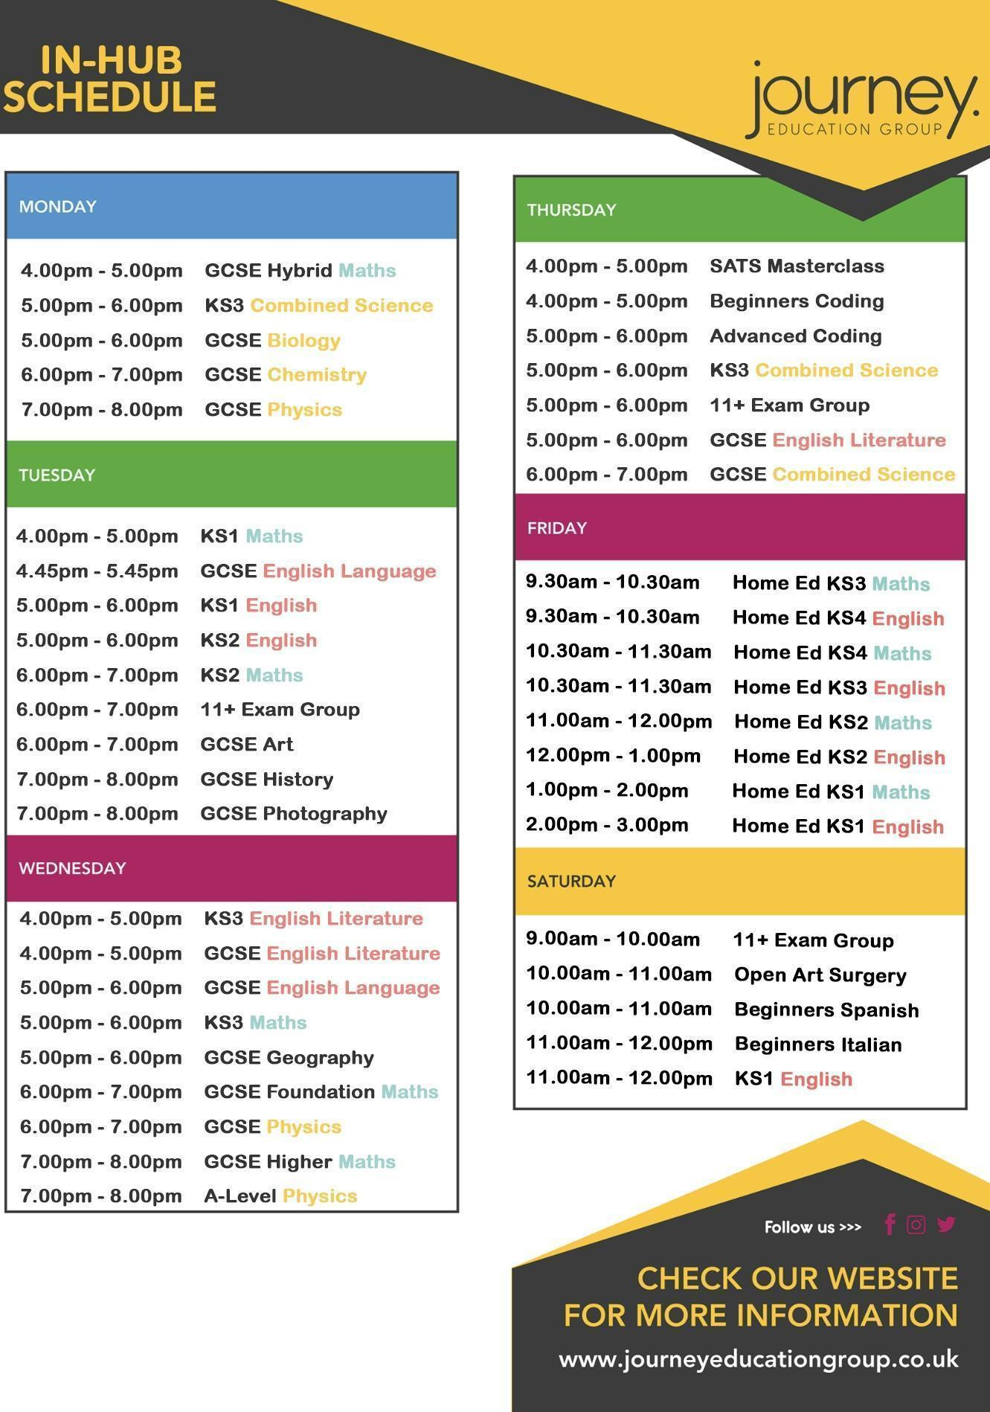
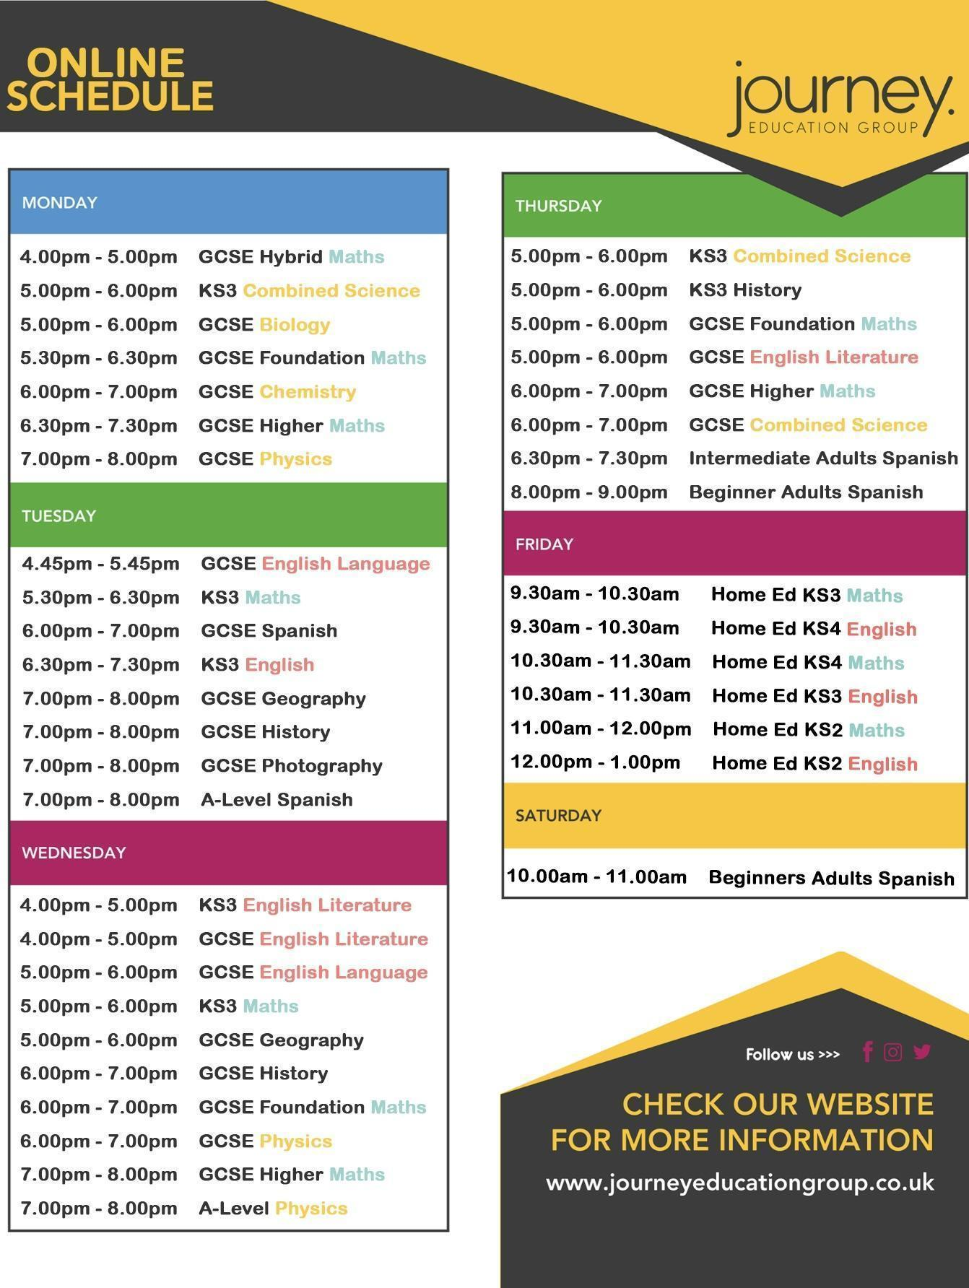

Safeguarding Information
At Journey, we are committed to the safety and happiness of our students.

Are you feeling unwell or unsafe?
Are you worried about a friend, student or family member?
Does something not feel right?
Share your concerns with us in our safeguarding postbox or
Please speak to the
Journey Independent Child Safeguarding Leads
Email: safeguarding@journeyeducationgroup.co.uk

Angela or Naomi


If you’re worried, tell someone.
In an emergency dial 999
For advice if you’re not in school, ring the NSPCC: 0808 800 5000
or Childline: 0800 1111

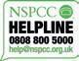
Maths Formulae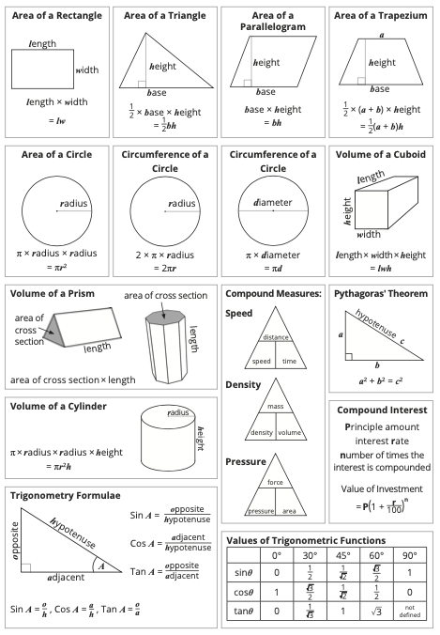

Navigating ADHD: Your Strengths, Your Success
Living with ADHD (Attention Deficit Hyperactivity Disorder) might sometimes feel like a challenge, but it's crucial to recognize that you possess unique strengths and qualities that can empower you to excel. Here are some tips to help you thrive:

1. Embrace Your Uniqueness:
Remember, having ADHD doesn’t define your worth or potential. Embrace your individuality, creativity, and unique way of thinking. Many successful people have ADHD and have turned their differences into strengths.

2. Understand Your Challenges:
Learn about ADHD—understanding your challenges is the first step in overcoming them. Talk to your healthcare provider, read books, or join online communities where you can connect with others who share similar experiences.

3. Develop Strategies:
Work with your teachers, parents, and counsellors to create personalised strategies that help you stay focused and organised. Simple tools like planners, reminders, and breaking tasks into smaller steps can make a significant difference.

4. Advocate for Yourself:
Don't be afraid to advocate for your needs. Let your teachers and peers know what support you require to succeed academically and socially. Communication is key.

5. Use Your Energy Wisely:
Channel your energy into activities you’re passionate about. Sports, arts, or any hobby can be an excellent outlet for your energy and a way to build self-confidence.

6. Practice Self-Compassion:
Be kind to yourself. Don’t compare your progress with others. Acknowledge your efforts and achievements, no matter how small they may seem. You are doing your best, and that's enough.

7. Break Tasks into Smaller Steps:
When faced with overwhelming tasks, break them down into smaller, manageable steps. Tackling one part at a time can make even the most daunting task feel achievable.

8. Build Supportive Relationships:
Surround yourself with friends and family who understand and support you. Healthy relationships are essential for emotional well-being.

9. Learn Stress Management Techniques:
Practice relaxation techniques such as deep breathing, meditation, or yoga. Managing stress can help you focus and maintain a positive outlook.

10. Stay Organised:
Use tools like calendars, reminders, and apps to stay organised. Creating routines and sticking to schedules can help you manage your time effectively.

11. Believe in Your Potential:
Believe in yourself. You have unique strengths, creativity, and resilience. With determination and the right support, you can achieve your goals and dreams.
Apps to help support your learning for Key Stage 3 and Key Stage 4
- BBC Bitesize: Offers interactive resources and revision materials for various subjects and exam boards.
- Quizlet: Allows students to create flashcards and play educational games to enhance learning and revision.
- Khan Academy: Provides instructional videos and practice exercises for a wide array of subjects, including mathematics, science, and humanities.
- Seneca: Offers interactive courses aligned with the curriculum, aiding students in revision and learning new topics.
- Duolingo: A language learning app that makes learning languages fun and interactive.
- Gojimo: Provides exam board-specific quizzes and study material for various subjects.
- Edmodo: A platform connecting students and teachers, facilitating discussions, file sharing, and assignment management.
- Scribble: An app for digital note-taking, enabling students to organise their study materials efficiently.
- Mathway: A maths problem solver that provides step-by-step explanations for a wide range of maths problems.
- GeoGebra: An interactive maths app that covers geometry, algebra, spreadsheets, graphing, statistics, and calculus.
- StudyBlue: Helps students create, share, and study digital flashcards.
- Evernote: A note-taking app that allows students to keep their notes organised, including text, images, and audio recordings.
- YouTube has some excellent GCSE revision resources too

Be Smart, Stay Safe: Your Guide to Responsible Social Media Use

1. Think Before You Post:
- Respect Privacy: Don’t share personal information like your address or phone number.
- Be Mindful: Consider how your posts may be interpreted and if they could be hurtful or offensive to others.

2. Inappropriate Images:
- Think Twice: Never share explicit, inappropriate, or compromising photos of yourself or others.
- Respect Boundaries: Don’t pressure others to share such images, and report anyone who does.

3. Online Respect:
- Be Kind: Treat others online as you would in person. Avoid cyberbullying and respect different opinions.
- Think Empathy: Remember, there’s a real person behind every screen.

4. Legal Information:
- Age Restrictions: Many social media platforms have age limits; make sure you meet the minimum age requirements.
- Copyright: Don’t use someone else’s work without permission, including images, videos, or music.
- Consequences: Sharing inappropriate images, cyberbullying, or harassment can lead to serious legal consequences.

5. Security Measures:
- Privacy Settings: Understand and use privacy settings to control who can see your posts and information.
- Strong Passwords: Use strong, unique passwords for each of your accounts to prevent hacking.
- Two-Factor Authentication: Enable this feature for an extra layer of security.

6. Mental Health Matters:
- Limit Screen Time: Balance your online and offline life. Excessive social media use can affect mental well-being.
- Reach Out: If you’re feeling upset or threatened, talk to a trusted adult, teacher, or a helpline like Childline.

7. Reporting and Blocking:
- Report Abuse: Report any form of harassment, bullying, or inappropriate content to the platform and, if necessary, to the police.
- Block Harmful Users: Don’t hesitate to block individuals who make you uncomfortable or engage in negative behaviour.

8. Stay Informed:
- Updates: Be aware of changes in social media platforms’ terms of service and privacy policies.
- Awareness: Stay informed about online trends, scams, and potential risks.

Remember: Your Online Presence is Permanent!
- Think Long-Term: What you post now can affect your future opportunities, friendships, and relationships.
- Digital Footprint: Your online activities leave a trace; ensure it’s a positive one.
Stay Safe, Stay Smart!
For more information and support, visit UK Safer Internet Centre: www.saferinternet.org.uk

R.E.S.P.E.C.T. in the Classroom:
R - Responsibility:
- Complete assignments on time.
- Bring necessary materials to class.
- Respect others' belongings and school property.
E - Engage:
- Actively participate in class discussions.
- Listen attentively when others are speaking.
- Be open to new ideas and perspectives.
S - Support:
- Help classmates in need.
- Encourage and uplift each other.
- Respect diverse opinions and backgrounds.
P - Punctuality:
- Be on time for every class.
- Respect others' time; avoid disruptions.
- Manage your time wisely to meet deadlines.
E - Empathy:
- Understand and share others' feelings.
- Be kind and considerate to classmates.
- Walk in others' shoes; be compassionate.
C - Courtesy:
- Use polite language and manners.
- Respect personal space and boundaries.
- Wait your turn; be patient and respectful.
T - Tolerance:
- Accept and appreciate differences.
- Avoid prejudice and discrimination.
- Celebrate diversity within the classroom.
Growth Mindset at Journey
- Embrace challenges, they fuel your growth.
- Learn from failures; they're stepping stones.
- Effort leads to improvement; never give up.
- Embrace criticism; it's a chance to learn.
- Believe in your ability to grow and succeed!

Journey Post 16 Provision



Published by Journey Alternative Provision © 2025. All rights reserved.

Author | Angela Cousins | Journey Alternative Provision Managing Director

