**Journey Independent School**

**Secondary Student Handbook**

**September 2025**



**Contents**

Contents

Congratulations

Agreement

Academic Year

Alternative Provision: The Secondary Day

The National Curriculum

Bullying

What should I do if...?

Student Voice

Safeguarding Information

Maths Formulae

Navigating ADHD

Apps that Support Learning

Responsible Social Media Use

R.E.S.P.E.C.T in the Classroom

Meet the Teachers

**Congratulations on joining us here at Journey Education Group!**

Starting a new place of study is an exciting time and an incredible opportunity.

At Journey we aim to ensure that we work with you as an individual to ensure that you have the confidence, courage, skillset, coping mechanisms and outstanding teaching that will enable you to be successful in your next steps.

This new setting is a unique opportunity to ensure that you make quick progress in achieving your goals. It is important that you set these goals high. Think about how we can help you to achieve and try your best everyday. That is all we ask. Change can sometimes be unsettling. However, at Journey we try to make sure that you get all the information that you need to make this change as easy as possible.

The key to starting well at a new provision is to make sure that you are clear about the expectations that we have of you. Although we have high expectations in terms of your learning, your progress, your attitude towards learning and behaviour and also how you develop your character as you grow up and move towards becoming a young adult, we also work very closely with you to ensure that you have both the opportunity and support to do so.Make sure that you read the home- school agreement and try your best. It won’t always be smooth going - but we always need to come back to our key rule: Respect.

Finally, enjoy your time here. Those students that get the most out of education are the ones that throw themselves into the experience. There is plenty on offer here.

I am looking forward to meeting you over the next few months and getting to know more about your own aspirations.

Good luck.

*Angela Cousins*

**Home/Journey Agreement**

Our Aims

* To generate an enthusiasm for learning amongst the students, so that they willingly seek to gain knowledge and understanding about the world around them.
* To provide students with the guidance, information and resources necessary to help them learn and make progress.
* To teach students the skills necessary for effective and efficient learning.
* To provide students with a positive learning environment.
* To develop a sense of pride amongst the students, so that they always aim to achieve the highest possible standards of work in all subjects.
* To foster the personal qualities, skills and self-confidence necessary for success in their chosen career and personal life.
* To develop amongst all students a sense of respect for themselves, other individuals, their own communities as well as others, plus their environment.

As a provision we undertake to:

* Provide a secure, welcoming and high quality learning environment.
* Care for each student’s emotional health and wellbeing.
* Deliver the National Curriculum and provide a broad and balanced education which aims to meet the individual needs of each student.
* Ensure that appropriate home learning is set, marked and monitored.
* Report regularly to parents and provide opportunities to discuss students’ progress.
* To support parents/carers through the period of their child’s transition to Journey Independent School..
* Contact parents/carers if there are concerns about attendance, punctuality, behaviour or progress.
* Respond sensitively and promptly to any concern or complaint raised by a parent/carer or student.
* Provide information and guidance about careers and higher education.
* Acknowledge, celebrate and reward students’ success and progress in all its forms.
* Create opportunities to enrich and enhance student experiences .

Signed (Journey Independent School)

As a Student of Journey, I undertake to:

* Attend school punctually and with minimum absence.
* Dress appropriately for a school day
* Bring necessary equipment and books
* Complete classwork and home learning as well as I can.
* Ask teachers for help when I have problems with my work and not give up when work is hard.
* Behave responsibly and considerately at all times both in Journey and in the wider community.
* Conduct myself in such a way as to enhance Journey’s reputation.
* React positively to a teacher’s reasonable instructions.
* Seek help from the Journey team if I have a concern or need help or guidance.
* Listen to and act upon advice to develop my academic progress and all other areas of Journey life.
* Observe Journey’s rules and Code of Conduct.
* Engage with any Enrichment Programmes offered by Journey to widen my experiences in life.

Signed (Student)

As Parents and Carers we undertake to:

* To support the aims and ethos of the school while encouraging my/our child
* Ensure that my/our child attends school punctually and with minimum absence.
* Ensure that my/our child is appropriately dressed for a school day.
* Ensure that my/our child completes all home learning set to the best of his/her ability and in reasonable working conditions.
* Attend Parents’ Consultation Evenings and meetings about my/our child’s progress.
* Support my/our child to achieve learning and progress targets by being active learners.
* Not take my/our child out of school during term time without the explicit permission of the centre manager.
* Encourage my/our child to participate in extracurricular activities.
* Recognise and support the rewards and sanction procedures of the school.
* Advise the school of any concerns or problems which might affect my/our child’s progress.
* Work constructively and cooperatively in partnership with the school to resolve any concerns about attendance, punctuality, behaviour or work.

Signed (Parent/Carer)

**The Academic Year**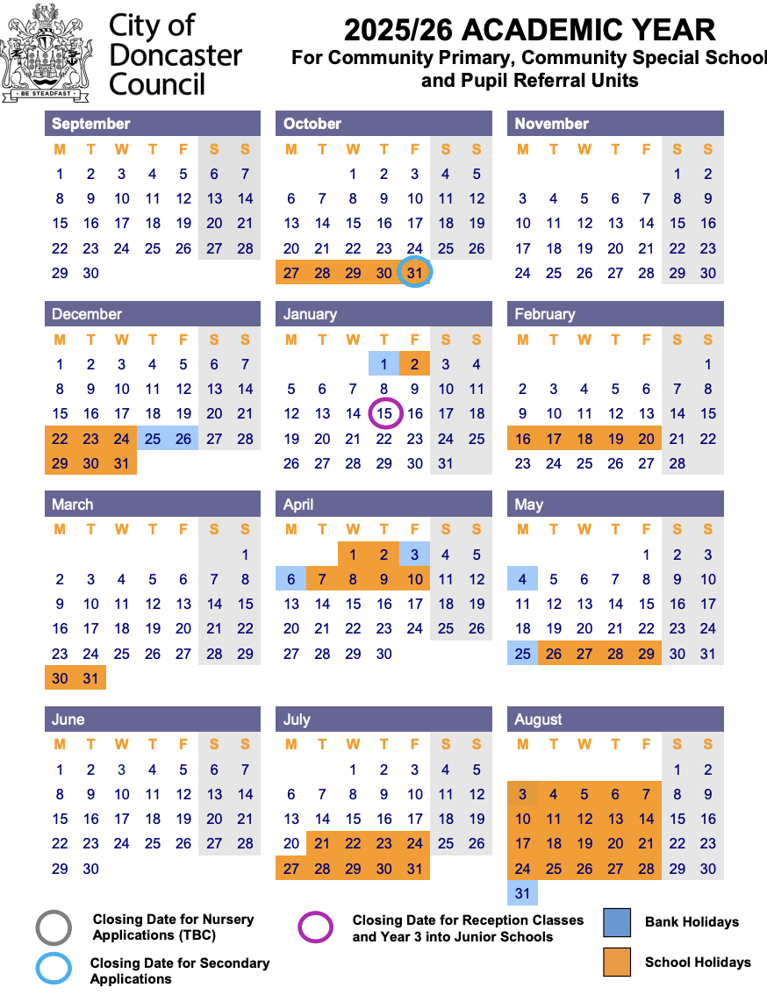

**Alternative Provision: The Secondary Day**

| 9:30 am – 9.45 am | Pupils Arrive, Registration and check in - set your target |
| --- | --- |
| 9.45 am – 10:45 am | Lesson 1  Core subjects (maths and English) are taught in lessons 1 and 2. |
| 10:45 am – 11:00 am | Break |
| 11:00 am – 12:00 pm | Lesson 2  Core subjects (maths and English) are taught in lessons 1 and 2. |
| 12:00 pm – 12:30 pm | Lunchtime |
| 12:30 pm – 1:30 pm | Lesson 3  Afternoon lessons will usually relate to our topic and may include humanities, sciences, art, DT etc. |
| 1:30 pm – 2:30 pm | Lesson 4  Afternoon lessons will usually relate to our topic and may include humanities, sciences, art, DT etc. |
| 2:30 pm – 2:45 pm | Break |
| 2:45 pm – 3:30 pm | Lesson 5  Growth/PE/ICT lesson including reflections on daily target |

**Reports and Parents Evening Dates**

**Term 1 - Autumn**

* 6th November – Autumn Term 1 Progress Report
* 8th January – Autumn Term 2 Progress Report
* 8th January - Parents Evening

**Term 2 - Spring**

* 26th February – Spring Term 1 Progress Report
* 16th April – Spring Term 2 Progress Report
* 16th April - Parents Evening

**Term 3 - Summer**

* 4th June – Summer Term 1 Progress Report
* 9th July - Parents Evening
* 16th July – End of Year Reports

**The National Curriculum**

The National Curriculum provides pupils with an introduction to the essential knowledge that they need to be educated citizens. It also helps engender an appreciation of human creativity and achievement. Journey strives to ensure support pupils to become:

* Successful learners who enjoy learning, make progress and achieve
* Confident individuals who are able to live safe, healthy and fulfilling lives
* Responsible citizens who make a positive contribution to society.

The National Curriculum is just one element in the education of every child. There is time and space in the placement each week to range beyond the National Curriculum specifications. Journey prides itself on the ability to stretch and challenge learners to take them beyond expectations. The National Curriculum provides an outline of core knowledge around which teachers can develop exciting and stimulating lessons to promote the development of pupils’ knowledge, understanding and skills. This is part of a wider curriculum that we use to help grow the learner as a whole person.

**Bullying**

We have zero tolerance for bullying at Journey.

What are the signs and symptoms of bullying? A person may indicate by signs or behaviour that they are being bullied.

Everyone should be aware of these possible signs and should investigate if the person:

– is frightened of walking to or from school or changes route

– doesn’t want to go on public transport to school

– begs to be driven to school

– changes their usual routine

– begins to truant

– becomes withdrawn, anxious, or lacking in confidence

– becomes aggressive, disruptive or unreasonable

– starts stammering

– threatens or attempts suicide

– threatens or attempts to run away

– feels ill in the morning

– asks for money or starts stealing money

– has unexplained cuts or bruises

– is frightened to say what’s wrong

– is afraid to use the internet or mobile phone

– is nervous and jumpy when a cyber message is received

**Reporting bullying at Journey**

You should report bullying immediately if it happens to you or a friend.

How to report bullying

– complete a statement which you can put in the anonymous ideas box

– Tell a member of staff

**What should I do if...**

| I’m running late? | Ask your parent/carer to let us know by calling 01302 796090 |
| --- | --- |
| I am being bullied. | Tell someone – your tutor, a parent, a teacher or a friend. |
| I have a dental/medical appointment? | Ask your parent/carer to let us know by calling 01302 796090 |
| I lost something? | Lost property is kept in the office.  Please leave valuables at home where possible. |
| I don’t understand a home learning task? | See your subject teacher for help. |
| I have forgotten to bring something to school? | Explain to your subject teacher at the start of the lesson. |
| I got something confiscated? | Items will be returned at the end of the learning day. |
| I don’t feel well? | Tell your teacher. |
| I am absent | Get a parent/carer to phone us on 01302796090 |
| I take medication? | Leave all medication at the office. Ask your parent/carer to inform the office and complete a medication form. |

# 

# Student Voice

Student Voice is a huge part of life at Journey Education Group. Students have their own input into decision making at JEG. We want you to explore other positions of responsibility. The skills students get from taking part in Student Voice are important for getting into college, sixth form and University. They show your dedication to your education and development.

**Uniform Policy**

At Journey, we do not have a uniform policy and encourage students to wear clothing that makes them feel comfortable and confident, as we believe this supports their focus and learning. However, we ask that students refrain from wearing pyjamas, as they are not suitable for a school environment. Additionally, we do not permit balaclavas for safety purposes. Regarding jewellery, we allow small studs and watches, but we ask that students leave valuable items at home to minimize the risk of loss or theft. Our goal is to create an environment where students can be relaxed and focused on their education.

**Healthy Eating**

At Journey Education Group we provide a free, healthy hot lunch every day on a 2 week rolling menu to any student in receipt of Free School Meals (FSM). A copy of this can be provided on request, if you would like a copy of this please email admin@journeyeducationgroup.co.uk

For any student not in receipt of FSM, we ask that parents or carers provide an appropriate packed lunch for their child. As we continue to support the growth and development of our students at Journey Education Group, we ask that packed lunches are nutritious and in accordance with the NHS Eatwell Plate guidelines.

https://www.nhs.uk/live-well/eat-well/food-guidelines-and-food-labels/the-eatwell-guide/

A balanced diet is essential for our children's physical and mental well-being. It provides them with the energy and nutrients they need to focus, learn, and thrive throughout the day.

Additionally, fizzy, energy, and isotonic drinks are not permitted at Journey Education Group. We believe that providing our students with healthy choices contributes positively to their overall school experience.

# Safeguarding Information

At Journey Education, we are committed to the safety and happiness of our students.

Are you feeling unwell or unsafe?

Are you worried about a friend, student or family member?

Does something not feel right?

**Please speak to the**

**Journey Education Child Safeguarding Leads**



Angela or Tom



**Maths Formulae**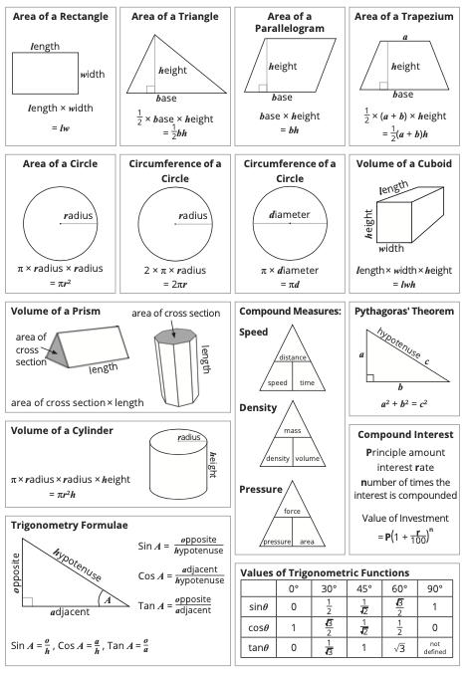

**Navigating ADHD: Your Strengths, Your Success**

Living with ADHD (Attention Deficit Hyperactivity Disorder) might sometimes feel like a challenge, but it's crucial to recognize that you possess unique strengths and qualities that can empower you to excel. Here are some tips to help you thrive:

### 1. Embrace Your Uniqueness:

Remember, having ADHD doesn’t define your worth or potential. Embrace your individuality, creativity, and unique way of thinking. Many successful people have ADHD and have turned their differences into strengths.

### 2. Understand Your Challenges:

Learn about ADHD—understanding your challenges is the first step in overcoming them. Talk to your healthcare provider, read books, or join online communities where you can connect with others who share similar experiences.

### 3. Develop Strategies:

Work with your teachers, parents, and counsellors to create personalised strategies that help you stay focused and organised. Simple tools like planners, reminders, and breaking tasks into smaller steps can make a significant difference.

### 4. Advocate for Yourself:

Don't be afraid to advocate for your needs. Let your teachers and peers know what support you require to succeed academically and socially. Communication is key.

### 5. Use Your Energy Wisely:

Channel your energy into activities you’re passionate about. Sports, arts, or any hobby can be an excellent outlet for your energy and a way to build self-confidence.

### 6. Practice Self-Compassion:

Be kind to yourself. Don’t compare your progress with others. Acknowledge your efforts and achievements, no matter how small they may seem. You are doing your best, and that's enough.

### 7. Break Tasks into Smaller Steps:

When faced with overwhelming tasks, break them down into smaller, manageable steps. Tackling one part at a time can make even the most daunting task feel achievable.

### 8. Build Supportive Relationships:

Surround yourself with friends and family who understand and support you. Healthy relationships are essential for emotional well-being.

### 9. Learn Stress Management Techniques:

Practice relaxation techniques such as deep breathing, meditation, or yoga. Managing stress can help you focus and maintain a positive outlook.

### 10. Stay Organized:

Use tools like calendars, reminders, and apps to stay organised. Creating routines and sticking to schedules can help you manage your time effectively.

### 11. Believe in Your Potential:

Believe in yourself. You have unique strengths, creativity, and resilience. With determination and the right support, you can achieve your goals and dreams.

**Apps to help support your learning for Key Stage 3 and Key Stage 4**

* BBC Bitesize: Offers interactive resources and revision materials for various subjects and exam boards.
* Quizlet: Allows students to create flashcards and play educational games to enhance learning and revision.
* Khan Academy: Provides instructional videos and practice exercises for a wide array of subjects, including mathematics, science, and humanities.
* Seneca: Offers interactive courses aligned with the curriculum, aiding students in revision and learning new topics.
* Duolingo: A language learning app that makes learning languages fun and interactive.
* Gojimo: Provides exam board-specific quizzes and study material for various subjects.
* Edmodo: A platform connecting students and teachers, facilitating discussions, file sharing, and assignment management.
* Scribble: An app for digital note-taking, enabling students to organise their study materials efficiently.
* Mathway: A maths problem solver that provides step-by-step explanations for a wide range of maths problems.
* GeoGebra: An interactive maths app that covers geometry, algebra, spreadsheets, graphing, statistics, and calculus.
* StudyBlue: Helps students create, share, and study digital flashcards.
* Evernote: A note-taking app that allows students to keep their notes organised, including text, images, and audio recordings.
* YouTube has some excellent GCSE revision resources too

### 

### 

### Be Smart, Stay Safe: Your Guide to Responsible Social Media Use

#### 1. Think Before You Post:

* Respect Privacy: Don’t share personal information like your address or phone number.
* Be Mindful: Consider how your posts may be interpreted and if they could be hurtful or offensive to others.

#### 2. Inappropriate Images:

* Think Twice: Never share explicit, inappropriate, or compromising photos of yourself or others.
* Respect Boundaries: Don’t pressure others to share such images, and report anyone who does.

#### 3. Online Respect:

* Be Kind: Treat others online as you would in person. Avoid cyberbullying and respect different opinions.
* Think Empathy: Remember, there’s a real person behind every screen.

#### 4. Legal Information:

* Age Restrictions: Many social media platforms have age limits; make sure you meet the minimum age requirements.
* Copyright: Don’t use someone else’s work without permission, including images, videos, or music.
* Consequences: Sharing inappropriate images, cyberbullying, or harassment can lead to serious legal consequences.

#### 5. Security Measures:

* Privacy Settings: Understand and use privacy settings to control who can see your posts and information.
* Strong Passwords: Use strong, unique passwords for each of your accounts to prevent hacking.
* Two-Factor Authentication: Enable this feature for an extra layer of security.

#### 6. Mental Health Matters:

* Limit Screen Time: Balance your online and offline life. Excessive social media use can affect mental well-being.
* Reach Out: If you’re feeling upset or threatened, talk to a trusted adult, teacher, or a helpline like Childline.

#### 7. Reporting and Blocking:

* Report Abuse: Report any form of harassment, bullying, or inappropriate content to the platform and, if necessary, to the police.
* Block Harmful Users: Don’t hesitate to block individuals who make you uncomfortable or engage in negative behaviour.

#### 8. Stay Informed:

* Updates: Be aware of changes in social media platforms’ terms of service and privacy policies.
* Awareness: Stay informed about online trends, scams, and potential risks.

#### Remember: Your Online Presence is Permanent!

* Think Long-Term: What you post now can affect your future opportunities, friendships, and relationships.
* Digital Footprint: Your online activities leave a trace; ensure it’s a positive one.

Stay Safe, Stay Smart!

***For more information and support, visit UK Safer Internet Centre:***[***www.saferinternet.org.uk***](http://www.saferinternet.org.uk)

**R.E.S.P.E.C.T. in the Classroom:**

R - Responsibility:

* Complete assignments on time.
* Bring necessary materials to class.
* Respect others' belongings and school property.

E - Engage:

* Actively participate in class discussions.
* Listen attentively when others are speaking.
* Be open to new ideas and perspectives.

S - Support:

* Help classmates in need.
* Encourage and uplift each other.
* Respect diverse opinions and backgrounds.

P - Punctuality:

* Be on time for every class.
* Respect others' time; avoid disruptions.
* Manage your time wisely to meet deadlines.

E - Empathy:

* Understand and share others' feelings.
* Be kind and considerate to classmates.
* Walk in others' shoes; be compassionate.

C - Courtesy:

* Use polite language and manners.
* Respect personal space and boundaries.
* Wait your turn; be patient and respectful.

T - Tolerance:

* Accept and appreciate differences.
* Avoid prejudice and discrimination.
* Celebrate diversity within the classroom.

Growth Mindset at Journey

* Embrace challenges, they fuel your growth.
* Learn from failures; they're stepping stones.
* Effort leads to improvement; never give up.
* Embrace criticism; it's a chance to learn.
* Believe in your ability to grow and succeed!

**Journey Education Group**

Published by Journey Education Group © 2025. All rights reserved.

Author | Angela Cousins | Journey Education Group Managing Director