**Journey Education Group**

**Team Handbook**

**Alternative Provision, Short Breaks & One-to-One.**

**January 2024**





**Contents**

Journey Education Group Information **3**

Aims of Journey **4**

Journey Leadership **5**

Term Dates 2023-2024 **6**

AP Primary Day **7**

AP Secondary Day **8**

The Learning Day **9**

The National Curriculum **10**

Staff Charter **11**

Becoming Part of the Journey Family **12**

Safeguarding **12**

Health & Safety **13**

Sickness and Absence Procedures **17**

Car Parking **17**

Staff Meetings **17**

Continuing Professional Development **17**

Parent Communications **18**

Behaviour Management 18

Staff Code of Conduct **18**

Observation Schedule **19**

Assessment Schedule **19**

Staff Training **19**

Journey Calendar **23**

Journey is an innovative one-stop provision that crafts individual learning journeys that meet the needs of learners of all ages. Whether that be stretch and challenge, scaffold and support, extra studies, or simply moulding an educational system that works for them, as part of a planned learning journey, just for fun, therapeutic or as part of a learning needs package

Our Doncaster Learning Hub is set in the beautiful scenic grounds of Woodfield Park, yet our reach spans the whole of the UK as well as the far-flung corners of the globe with online accessibility in all lessons, online courses and workshops, staff training, exam support, curriculum writing and assessment support.

Our Vision is to create an Alternative Provision that can help each and every learner overcome all barriers to access a successful and happy learning journey, Making Learning Inspirational.

Safe, Happy and Learning Together: We aim to build foundations and provide opportunities to create confident, aspirational and independent members of the community

Journey Learning Hub Contact Details:

Angela Cousins – Managing Director  
Oak Tree Lodge, Woodfield Park, Tickhill Road  
Doncaster   
DN4 8QN  
01302 492239  
JourneyEducationGroup.co.uk

**Journey Aims**

Our values are encompassed in our statements of ‘Let’s put your Journey First’ and ‘Making Learning inspirational’.

Through this, we seek to develop the ideology: building foundations and providing opportunities to create confident, aspirational and independent members of our community.

Journey is committed to raising standards with learners who are disaffected, disengaged, MLD, SLCN, SEMH, ASD, ADHD working towards educational and social inclusion, as well as a particular focus on stretch and challenge and raising aspirations, in partnership with the community to develop as a Centre of Excellence promoting the highest expectations, whilst meeting individual needs.

To develop and maintain an inclusive, caring and supportive community for pupils and staff, promoting high-quality teaching and learning with GCSE pathways, positive relationships, high self-esteem and an understanding of and respect for cultural and ethnic diversity and beliefs.

To provide a broad, balanced and carefully differentiated curriculum that ensures all pupils achieve their full potential academically, morally, socially, physically and spiritually, irrespective of gender, culture, race or disability.

To provide a wide, varied and relevant range of high-quality and well-resourced curricular activities that stimulate interests and prepare pupils for lifelong learning in the modern, inclusive, technological and multicultural world.

To ensure pupils develop confidence, self-esteem, independence, and respect for themselves and others, preparing them to be active, responsible and tolerant community members.

To ensure that pupils’ work and progress are monitored and evaluated, ensuring that recording procedures identify pupil needs and recognise a broad range of achievements.

To develop and maintain an effective continuing professional development programme for all staff that serves the needs of the whole organisation.

To provide a secure, welcoming, pleasant, clean, attractive and stimulating environment in which meaningful teaching and learning can take place.

To build positive partnerships with parents/carers/guardians/ Governors, the Local Authority, external agencies, schools and the wider community (industry, commerce and community groups).

**Senior Leadership Team**

Principal: Angela Cousins

Centre Manager - Sam Hanlon

Teaching and Learning Lead: Angela Cousins

Therapeutic SEND Lead: Tracey Page

Designated Safeguarding Lead – Sam Hanlon

Deputy Safeguarding Lead - Angela Cousins

Chair of Governors – Voluntary Business Sector panel - Mrs J Whitehead-Wilson

Voluntary Parent Governor Panel - Mrs S.Hanlon

**Alternative Provision: Primary Day**

| 9:30 am – 9:45 am | Check in: Students arrive and check into their classes |
| --- | --- |
| 9:45 am - 10.30 am | Lesson 1: Students arrive then move onto a therapeutic Activity |
| 10:30 am - 11.15 am | Morning  Lesson 2: Our primary pupils attend for different therapeutic or academic packages. The day will depend on this.  As an example: Our morning sessions enable pupils to develop their core skills through literacy and numeracy lessons. Depending on their need and skills, pupils will access these in either a typical lesson format or through Nurture and play. Some of our pupils will have access to Sensory Programmes and Therapy sessions during this time. Our morning session includes opportunities for outdoor play and snack time, modelled on a Nurture approach. |
| 11:15 am – 11:30 am | Morning Break |
| 11:30 am - 12:30 pm | Lesson 3 - As Lesson 2 |
| 12:30pm – 1:00 pm | Lunch - Lunch is supervised at all times and activities and stimulation will be provided: the creation of a safe space where relationships can be built with peers |
| 1:00 pm -  1:45 pm | Lesson 4 Our afternoon sessions enable pupils to continue their social and emotional development through theme-based learning. We support pupils in their independence through Child Initiated Learning and Role Play and thrive. Throughout the session pupils access both indoor and outdoor learning environments. The afternoon session includes opportunities for pupils to access discrete Humanities, Arts,DT, PE, ICT, forest school, dance,music, yoga but to name a few. |
| 1:45pm - 2:30 pm | Lesson 5 - As Lesson 4 |
| 2:30pm - 2:45pm | Afternoon Break |
| 2:45pm - 3:30pm | Lesson 6 - As Lesson 4 |

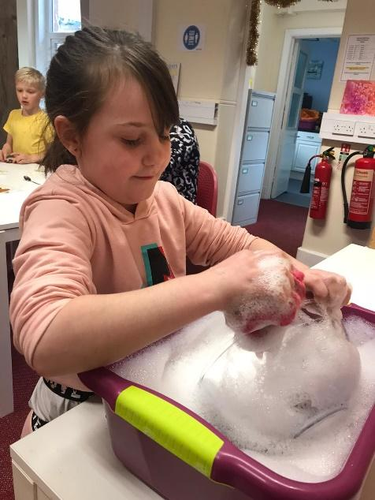

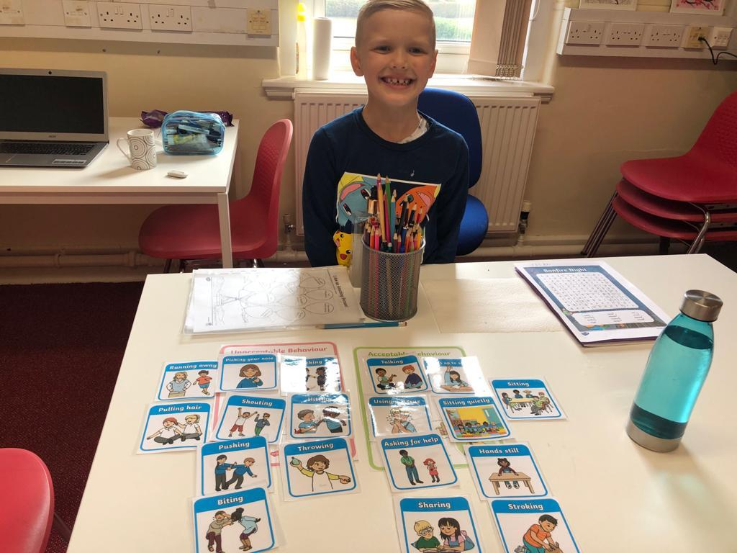

**Alternative Provision: The Secondary Day**

| 9:30 am – 9:45 am | Pupils Arrive and Registration with a check in activity |
| --- | --- |
| 9:45 am – 10:30 am | Lesson 1 - Academic Focus (see individual timetables) |
| 10:30 am – 11:15 am | Lesson 2 - Academic Focus (see individual timetables) |
| 11:15 am – 11:30 am | Break |
| 11:30 am – 12:00 am | Lesson 3 - Therapeutic Session (see individual timetables) |
| 12:00 - 12:15pm | Growth Programme and Reflection session |
| 12:15 - 12.30 pm | Monitor Duties - End of day |

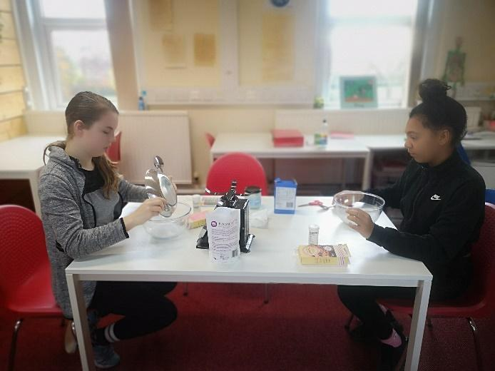

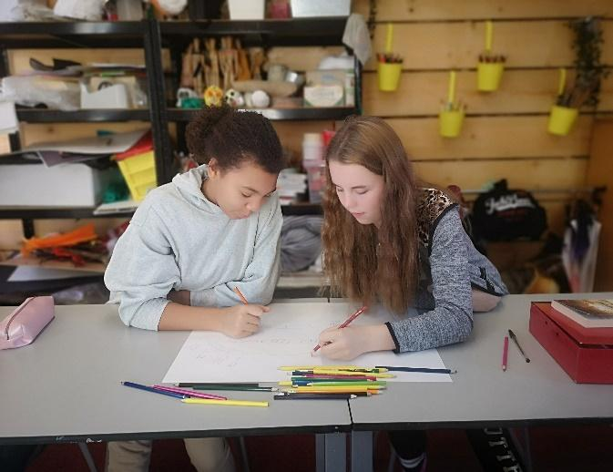

A Journey: Alternative Provision Day

**Morning Briefing**

A staff briefing takes place at 9am every morning in the office. All staff working that day are expected to attend. Punctuality is an important factor, if you are late for the day, you could miss essential information (especially in regard to safeguarding). If required, a weekly Briefing Sheet is produced and emailed to all staff, along with daily emails of notes from each morning’s Staff Briefing. Please ensure that you read these notes, as they may and will contain important information.

**Pupil Arrival**

Staff should be in place immediately following Briefing to welcome pupils, check in with their presentations that morning and make adjustments to staffing in their department if necessary.

**Morning Break/Lunchtime Arrangements**

Break time for pupils is between 11:15 and 11.30am.

Lunch time for pupils on a full day placement is 12.30pm – 1.00pm which will also be staff lunch, however staff are still responsible for student supervision during this time.

**End of Day Routines**

The majority of pupils are transported to and from the centre by car. Pupils should never leave before being passed over to the care of escorts or drivers. Parents collecting pupils must do so from the building. Classroom staff are responsible for ensuring this happens.

The National Curriculum

The National Curriculum provides pupils with an introduction to the essential knowledge that they need to be educated citizens. It also helps engender an appreciation of human creativity and achievement. Journey strives to ensure pupils become:

* Successful learners who enjoy learning, make progress and achieve
* Confident individuals who are able to live safe, healthy and fulfilling lives
* Responsible citizens who make a positive contribution to society.

The National Curriculum is just one element in the education of every child. Each week, there is time and space in the placement to range beyond the National Curriculum specifications. Journey prides itself on stretching and challenging learners to take them beyond expectations. The National Curriculum provides an outline of core knowledge around which teachers can develop exciting and stimulating lessons to promote the development of pupils’ knowledge, understanding and skills as part of the wider curriculum and growing the learner as a whole person.

However, the USP of Journey AP is GCSE and equivalent pathways. We want to debunk the myth that children with barriers to learning aren’t academic and to ensure that those pathways remain open to them regardless of their experiences of education thus far.

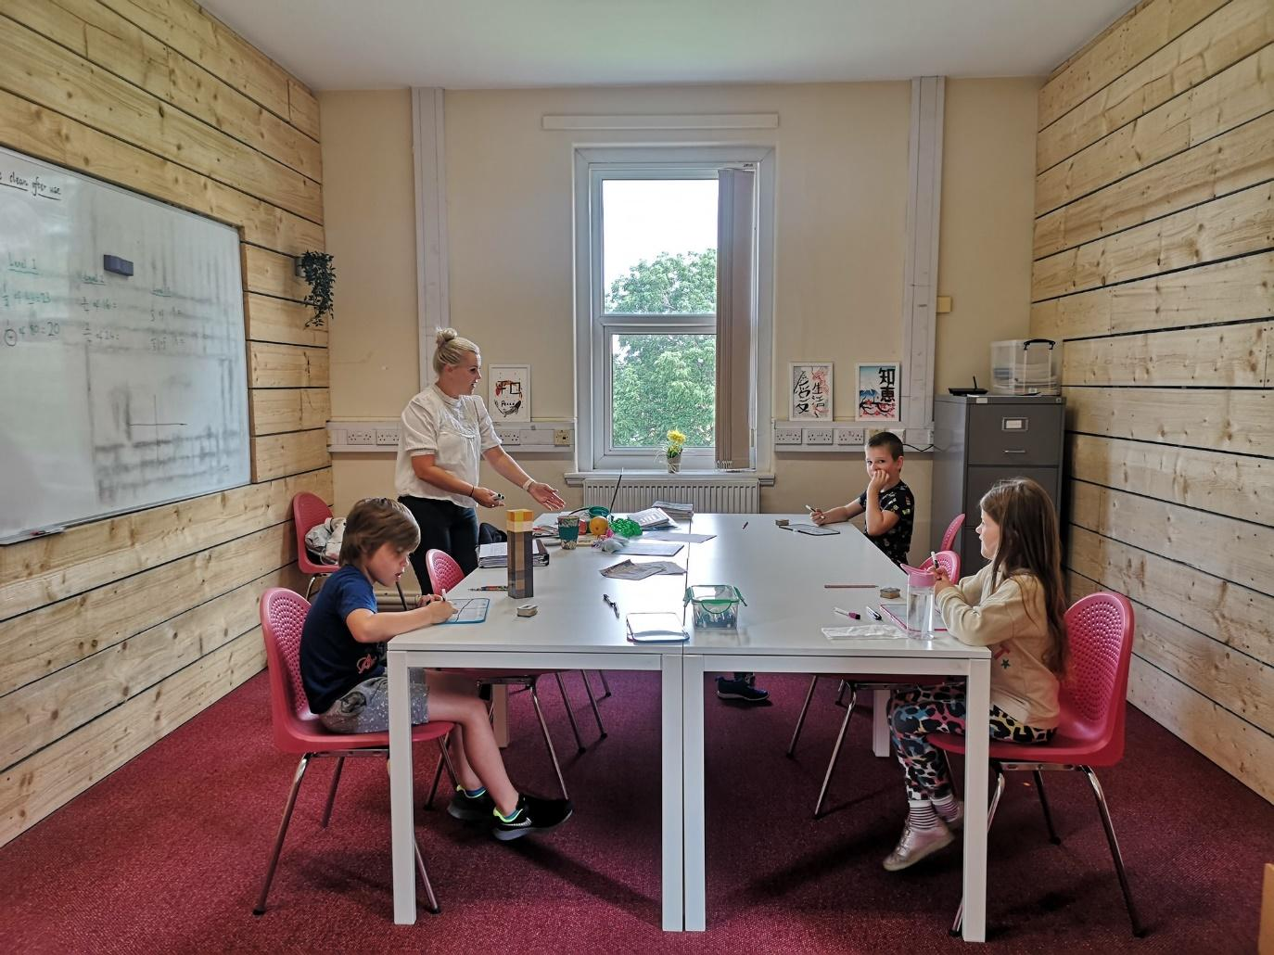

**Staff Charter**

Journey aims to ensure that everybody (employed and freelance) feels valued, supported and respected in their working environment. Through planned programmes of continued improvement, we want all staff to have the opportunity to develop their full potential, to feel encouraged to contribute new ideas and solve problems and to strive to improve our service delivery to our pupils, their parents and carers, Schools, the Local Authority and other agencies.

**What You Can Expect from Managers.**

* To work in an environment where safeguarding, supporting and developing pupils is paramount.
* To work in an environment protected from discrimination, bullying or harassment.
* To be kept informed and consulted where appropriate.
* To be given appropriate training and development to do your job successfully (for freelance staff this will be limited to expectations and capacity).
* To be treated fairly, consistently and be respected.
* To be encouraged to express ideas and to be listened to when raising concerns.

**What Managers Expect from You**.

* To be aware and understand the importance of safeguarding and supporting pupils and act on any safeguarding concerns immediately.
* To take responsibility to find out the information you need to fulfil your role, including being prepared and resourced for all your lessons, strive to be outstanding in your practice as well as give due consideration to marking and feedback to your learners.
* To take an active interest in improving your own performance through reflective practice to continually provide high quality lessons.
* To express ideas and concerns in a proactive, positive and enthusiastic way.
* To work in ways that safeguard the health, safety and welfare of yourself and others.
* To develop and use new skills and knowledge to improve your work.
* To recognise each other’s differences and treat each other with respect.
* To strive for success through diligence and flexibility in supporting the changing needs of the Journey team. For example, if a student you are working with fails to attend, you must use your time wisely in order to best make use of our resourcing
* To show commitment through excellent timekeeping and reporting absence promptly (pay and PDR will be affected if this isn’t the case).

**Becoming part of the Journey Family**

Whether employed or freelance, we want everyone to feel valued and appreciated and thus, feeling part of the family is important to us. Ways we aim to do this include:

Wellbeing chart.

We want to check in with each other every time you are at the Hub. There is a chart in the main office that you can complete to share how you are feeling to support each other and assist those who may need additional help.

Journeyer of the Month:

This is a way to celebrate you and your hard work. We will be making the selection each month based on your nominations and our observations. Contact Admin with the person and why you think they deserve this accolade by the end of the month's third week.

Postcards

Journey Postcards are available for you to send to students and staff. This is a way to celebrate and praise the students and also each other. Simply write your messages on the postcards and drop them into the office, and we will send these on your behalf. This is an integral part of our provision, and there is an expectation that you will take part.

**Safeguarding**

Safeguarding and promoting the welfare of children is everyone’s responsibility.

Safeguarding and promoting the welfare of children is defined by the Department for Education as:

* Protecting children from maltreatment
* Preventing impairment of children’s health or development
* Ensuring children are growing up in circumstances consistent with the provision of safe and effective care.
* Taking action to enable all children to have the best outcomes.

Child protection is a part of safeguarding and promoting welfare. It refers to the activity that is undertaken to protect specific children who are suffering, or are likely to suffer, significant harm.

Our Child Protection and Safeguarding Policy and procedures are available to all staff via the Journey website.   
All staff must ensure that they have read and understood our policy.

**Journey Safeguarding Team**

The Local Authority Designated Officer (LADO) is

Milovan Orlandich 01302 736784, Milovan.Orlandich@doncaster.gov.uk   
(Monday – Thursday 9.00am – 4.30pm)

Caroline Tanner- 01302 736473 (Monday, Tuesday and Thursday)

LADO Administrator - 01302 737332 LADO office: [LADO@doncaster.gov.uk](mailto:LADO@doncaster.gov.uk)  
LADO, Mary Woollett Centre, Danum Road, Doncaster, DN4 5HF

If you are concerned about a child’s welfare, you must submit the details via the Safeguard software as soon as possible before the end of the day.  
If your concerns relate to the actions/behaviour of a member of staff you should report this to the Designated Safeguarding Lead. If the concern relates to the Designated Safeguarding Lead, you should report this to the LADO.

**Health & Safety**

All staff have a personal responsibility for the health and safety of themselves, their colleagues, pupils and visitors. Our pupils are especially vulnerable, and staff need to be constantly alert for possible sources of danger.

It is also the duty of every member of staff to report any unsafe conditions to the Manager immediately. Each member of staff has a responsibility for drawing the Manager’s attention to their own personal needs for training and for not undertaking duties unless they are confident that they have the necessary competence. All staff have some health and safety responsibility and will be expected to have knowledge on what to do if an accident or incident occurs and be aware of the fire and first aid procedures.

All staff should read the Health and Safety policy available on the Journey website.  
  
**Safety During Curriculum Activities**

Staff should be aware of the Health and Safety Policy provisions particularly relating to Science, PE and DT.  
A copy of the Health and Safety Policy is available on the website.  
Staff taking children out of the Centre grounds should ensure that Risk Assessments have been completed before taking pupils off-site.  
  
 **Staff should also bear in mind the following points:**

* Children’s physical safety must be given priority over all other considerations.
* The behaviour of our children cannot always be predicted.
* Staff must keep each child in view; no child should be left to trail behind where they cannot be observed by staff, especially when near a road. When on visits, staff will be given nominated children and it is your responsibility to ensure that student is handed over to driver/parents/carers at the end of the day
* Please remember individual medication requirements for pupils.
* Supervision Staff must ensure the safety of pupils and must be vigilant when supervising in the outside areas, positioning themselves to allow for maximum supervision. No children should be sent to or left in the outside areas unsupervised.

**First Aid and Accident Reporting**

If you are concerned about the health of a child, please consult a First Aider.  
The First Aider will assess and then make arrangements for the child and inform a member of SLT.  
A list of first aiders is displayed in the Centre.   
All incidents of first aid should be reported, logged and parents informed.  
Children should not be sent home without the authorisation of the manager.  
All staff must be aware of Journey’s Health and Safety policy.   
All accidents involving pupils, staff or visitors should be reported to Sam Hanlon - Centre Manager. This form is available in the administration office. Minor accidents/incidents requiring first aid should be recorded with treatment details in the accidents book which is located in the office.

**Medication**

No pupil may be given prescribed medicines or Asthma Inhalers in the centre unless the parent/guardian gives written consent with instructions and the medicine is in the original container bearing his/her name and the recommended dosage.   
These must be locked away in a designated cupboard by a member of staff responsible for First Aid. Prescribed medicines/asthma inhalers etc will be administered, logged and signed by a qualified First Aider.   
The process of administering medication is coordinated by Sam Hanlon - Centre Manager. Journey can give pupils non-prescribed medication such as paracetamol, ibuprofen etc if parents/guardians have given their consent (this will need to be in writing).   
Parents can send in non-prescribed medication such as hayfever remedies, cough medicine etc for staff to administer to pupils but this must be in the original container and unopened/unused. Parents must also give written consent for these medications to be administered (in writing).  
If parents/guardians send non-prescription medications into the centre, these must be passed to the Centre Manager to arrange administration.

**Fire Procedures**

There are detailed instructions in every classroom about the nearest fire exit point and signs indicating those exit points.  
All staff should be aware of the evacuation details for all classrooms and the nearest call point should you discover a fire. In the event of an alarm, staff should evacuate pupils; do not stop to collect personal possessions.  
All staff should read the Fire Emergency Plan which is in the office and online.  
Journey has a fire safety risk assessment which is available in the office and online.  
There will be a fire drill at least once every term and alarm testing is undertaken regularly (see office for a schedule).

**Electrical Safety**

All staff should monitor the condition of plugs, cables and electrical equipment that they use and report to the manager any damaged electrical equipment or wiring. Portable appliance testing takes place annually. The use of multi-adaptors is to be avoided as is the use of extension leads.  
Journey also encourages staff and pupils to conserve energy at all times. All appliances should be switched off and unplugged before going home at night.

**Security**

No-one should be on site without a pass and staff should be aware of unidentified people around the centre and be prepared to challenge them or report their presence to the manager immediately.  
Entrance to the centre is carefully controlled and monitored by phone intercom in the first instance and a fobbed door control once inside.  
All staff responsible for opening or closing the building will be issued with a card entry pass which they must have at all times and must swipe in and out of the building.  
Staff must not lend passes/keys to pupils or other staff and notify the Manager of any lost passes/keys immediately.  
Visitors and staff as well as children will be required to sign in at reception (this is for Fire Safety purposes as well as monitoring visitations).

**We Welcome Visitors.**

Members of staff should inform the manager if they are expecting visitors or if special events are taking place in the centre. The manager will ensure that all arrangements are recorded in the Briefing. Every visitor is required to sign in when they arrive at the centre.

Fire and safeguarding guides and policies are available both on our shared drive area and hanging next to the intercom in the hall area as well as in the office. Visitors must remember to sign out when they leave the premises.

They should then be met by the member of staff who has made the appointment.No member of staff should allow a visitor entry to the centre unless they have an appointment with them and they have signed in. Do not allow people to ‘tailgate’ through any centre entrances/exits.

**Alcohol and Drugs:**

If there is any suspicion that staff or visitors are under the influence of alcohol or drugs, this must be reported immediately to the manager.  
Staff must not consume alcohol or be under the influence of alcohol or drugs (unless prescribed) whilst responsible for our students.

**Personal Injury and Possessions**

The behaviour of some of our pupils can sometimes be unpredictable and challenging.   
There is an increased risk of accidents or incidents that may lead to personal injury.  
Journey has Employers Liability Insurance, which covers legal liability in respect of the death or bodily injury only of any employee of the Journey, including any member of the Journey staff.  
All the same, people are indemnified personally in the event of a claim being directed against them. Staff are advised to consider their own personal injury position as this insurance does not cover them other than for ‘significant’ injury arising from negligence.  
Journey will not accept liability for claims arising from personal injury or damage to personal property. Personal possessions should not be left unattended.  
If you have valuable personal possessions, medication or money in your bag, then you are strongly advised to store these in the office.

**E–Safety/Acceptable Usage Policy**

Staff should read and sign the E-Safety Policy.  
Staff must keep pupil and staff information confidential and should not engage in any social networking site in such a way as could bring Journey or other staff into disrepute including communicating with children or parents on social media or through a personal email.  
Such action could lead to investigation and possible proceedings under the Staff and Freelance Disciplinary Policy. Further information can be found in the staff Code of Conduct and aforementioned policies.

**ICT Equipment**

Staff that are assigned portable ICT equipment must take care of the equipment that is issued to them. All ICT equipment must be securely stored and should be available for inspection when required. Any damaged/lost/stolen ICT equipment must be reported to the manager immediately. When students are using the computer suite, it is the responsibility of the educator in charge of the class to ensure all media is respected and cared for and any issues are reported to the centre manager immediately.

Equally when students are using equipment in your lesson, you remain responsible for that equipment in the same way as if it was yours and the guidelines remain as above.

**Telephones**

The use of personal mobile phones is outlined in the Staff Code of Conduct. Unless you are using your phone as part of the lesson, phones must be stored out of view and personal calls and general phone use is not permitted during your work or commissioned hours (unless of an emergency nature). We have a policy that we expect students to follow and this must be modelled by the same expectations from staff and freelancers. A failure to comply with this guidance will result in disciplinary procedures.

**Smoking**

Journey is a non-smoking environment, as is the whole of Woodfield Park.  
Staff wishing to smoke during break times must do so outside Woodfield Park and must not wear lanyards or badges that identify them with Journey. This includes traditional cigarettes, pipes, vaping equipment or e-cigarettes.

**Sickness and Absence Procedures**

**Sickness**

If you are not well enough to come to the centre or carry out your duties that day, please contact the office on 01302 492239 and Angela on 07915 604798 before 7am on the first day of absence (and all subsequent days) as well as emailing your cover work to [admin@journeyeducationgroup.co.uk](mailto:admin@journeyeducationgroup.co.uk) . Emailing cover work is an essential part of maintaining the work at the centre in your absence so that your students aren’t affected. If there is any issue with providing cover work that day, please contact Angela to inform her of the reasoning.

Absence impacts everyone in a team and so as a result we monitor and support all educators whether employed or freelance to maintain good standards of attendance to always ensure we deliver an outstanding service. We want to ensure everyone associated with Journey is supported with their physical/mental barriers to work.

For employed staff, the first two days of absence will be paid on full pay and the days following will be covered by SSP. Sick pay will not be paid to freelance staff, however freelance pay is at a higher rate to cover these situations.

For freelance educators - after the third separate incident of illness you will be required to attend a wellbeing meeting with Journey SLT to ensure fitness to proceed and to discuss next steps.

For employed Journey staff - a back to work wellbeing interview will be arranged after every absence.

Journey’s Management of Absence Policy is available in the office as well as on the drive.

**Leave of Absence Requests**

You must speak to the manager to request a Leave of Absence form. A turnaround of 72 hours must be expected before the outcome of the request is delivered and you can only be assured that it has been granted when you receive your slip back.  
Where possible, all medical appointments should be arranged outside of your duty hours.  
Emergency requests for leave need to be made directly with the manager in the first instance.

**Car Parking**

Staff should park in the Woodfield Park car parks, but should not park in the disabled bays to the side of the building nor on the double yellow lines outside the front of the building.

**Staff Meetings**

For AP workers, all teaching and learning support staff are required to attend daily meetings, unless directed otherwise by the Manager. SLT meetings are held Mondays and RAG and training meetings on Tuesdays. These are not optional and are mandatory to your contract. Intermittent emergency or information meetings may need to be called and any workers on the provision will be required to attend such as Ofsted.

Salaried staff will also be expected to deliver parent’s evenings once every term - again mandatory to your contract.

**Continuing Professional Development**

We are committed to developing the skills and expertise of all staff at Journey regardless of the project or employment status. Professional development increases staff knowledge about specific subjects. It allows time for teachers and support staff to discuss and share ideas with colleagues cross - curricula. The knowledge gained from professional development allows staff to keep pace with trends and philosophies, which assists both teaching and learning. Opportunities will be offered throughout the academic year, however if there is something you wish to explore, please contact Angela in the first instance to discuss, a training request will then need to be completed. If training is provided and the staff member leaves, there is a financial penalty for the training that will be invoked (please see contract for breakdown details).

**Parent Communications**

Parental Meetings - Be prepared for the unexpected, as parents may need to bring children to the meeting, so have materials that they can use in the room to minimise distractions. Having water and snacks available can be a kind and welcoming gesture as well. Be sure to have visuals available and organised, such as any student work or records that may be applicable to the meeting. When discussing academics, having visuals printed and prepared can assist parents in better conceptualising the learning process and how it relates to their child. Finally, prepare yourself emotionally. Strive to receive negative parent feedback through a professional lens, not a personal one.

Day to Day communication - Journey workers should not under any circumstances exchange personal contact details with any students or parents regardless of the project or the employment status. Contact with parents must be carried out in person or through Journey communications only. Failure to comply with these guidelines can result in both disciplinary and legal action.

**Non-Solicitation Agreement**

By accepting a position, freelance work or working in a volunteer capacity with Journey, you are agreeing to our Non-solicitation agreement. Working with Journey students in a personal capacity is strictly prohibited. The non-solicitation agreement is included in all Journey contracts for your perusal. In the event that you are already working in a professional and personal capacity prior to you joining the Journey Team, please bring this to the immediate attention of the Senior Leadership Team, so this can be logged.

**Notice Period**

We understand that everybody’s Journey is different, and the length of time that you will be with us may differ. If this time arises, we ask you to give us as much notice as possible in order to allow us time to fill your position and to cause minimal disruption to the students in your care but a minimum of one term. As per the freelance contract, a lack of this notice period will result in a financial penalty and refusal to issue a reference, unless under extenuating circumstances.

**Staff Code of Conduct**

The following code of conduct has been formulated to allow Journey to fulfil its functions and to establish procedures for the regulation of the conduct of the staff.   
This code of conduct applies to all employees, freelance workers and volunteers of Journey.   
  
This code aims to establish the usual standard of conduct expected of all employees whilst also reflecting the Core Values and Vision of Journey.  
It’s a combination of these regulations, standards and values that formulates the way in which an employee of Journey Education Group is expected to conduct themselves.  
This code of conduct:

* sets out minimum standards of behaviour for employees
* provides guidelines to help maintain and improve standards
* aims to protect the reputation of both employees and Journey

This code of conduct is not exhaustive and does not replace the general requirements of the law, common sense and good professional practice.   
A code of conduct is promoted with the aim of creating a cooperative workforce, where staff work as a team, have high values and respect each other; thus creating a strong morale and sense of commitment leading to increased productivity.  
As an employee, you must not put yourself in a position where duty and private interests conflict and you must not make use of your employment to further your private interests.

**Behaviour Management**

1. Positive reinforcement - Encouragement, praises, and rewards for good behaviour can go a long way in promoting positive behaviour among students.

2. Structured routine and consistency - Create a daily regimen that gives the students a sense of security and stability, and make sure to follow it consistently.

3. Use visuals - Implement the use of visual aids such as time tables, charts, and schedules to help students understand expectations and routines.

4. Break down tasks into manageable steps - Students with SEND may struggle with complex tasks, so breaking them down into smaller components makes them feel less daunting.

5. Clear expectations - Communicate clear and concise expectations to students at the start of each task or activity.

6. Redirecting behaviour - If a student is engaging in unacceptable behaviour, calmly interrupt and redirect them to a more appropriate behaviour.

7. Use positive language - Focus on communicating positively and supporting students to develop appropriate behaviours.

8. Provide opportunities for choice - Students will feel more empowered and engaged if given the opportunity to choose how they learn or what they learn.

9. Peer support and modelling - Encourage students to work collaboratively within small groups with peers who can model appropriate behaviours.

10. Restorative practice - Help students reflect on their actions and find ways to repair relationships that were damaged as a result of their behaviour.

It's important to remember that students with SEND may have different needs and challenges when managing their behaviour, so teachers may need to adapt these techniques to meet individual needs.

**Observation Schedule**

As part of our dedication to the growth of our learners, as well as our own growth as teachers, and middle and senior leaders, we are committed to learning from each other as much as possible. This observation schedule is fluid in terms of dates carried out, however the observation must be carried out by the date of the end of that period. SLT observations will be used in PDRs, where Peer and ML observations will be used in our own teacher growth plans.

**W/C Observation Focus**

25th Sept 23 Morning and Afternoon AP Observation

2nd Oct 23 Outreach AP Observation

6th Nov 23 Outreach Ap Observation

4th Dec 23 Morning and Afternoon AP Observation

4th Mar 23 Morning and Afternoon AP Observation

20th May 24 Outreach Ap Observation

10th Jun 24 Morning and Afternoon AP Observation

8th July 24 Outreach Ap Observation

**Assessment Schedule**

Regular monitoring, assessment and feedback is vital to a student's progress. Particularly home ed or AP students – who have no other teacher but you. Imagine trying to progress on your learning journey with absolutely no feedback other than occasionally verbally in a group. Therefore the assessment schedule must be applied with rigour to ensure we stretch our learners to beyond their potential. Feedback must then be given to students in a timely manner and numerical outcomes passed forward for recording.

**W/C Assessment**

7th Sept 23 Initial Assessment

12th Oct 23 Half Term Key Indicator Piece

14th Dec 23 End of Term Key Indicator Piece

12th Feb 24 Half Term Key Indicator Piece

21st Mar 24 End of Term Key Indicator Piece

2nd May 24 Half Term Key Indicator Piece

11th Jul 24 End of Term Key Indicator Piece

Data Collection: Data from Key Indicators is due exactly one week after the dates listed above for each KI. Data collection is a deadline not to be missed. (disciplinary action for those regularly missing data deadlines will be an action perused)

**Staff Training**

##### JOURNEY EDUCATION STAFF TRAINING 2023 - 2024

The Journey CPD encompasses both Mandatory and Optional elements. As some of our training is external and dependent on dates being released - we do not have a set schedule led by dates at the beginning of each year. However here is a list of the training units that are available:

MANDATORY TRAINING UNITS:

##### Safeguarding Level 1

* Safeguarding Level 2

##### Child Protection in Education

##### The Prevent Duty

##### Adverse Childhood Experiences (ACEs)

##### Dealing with a Disclosure

##### Child Exploitation

##### Child Neglect

##### Equality and Diversity

##### Keeping Children Safe in Education 2024

##### Looked After Children

##### Mental Wellbeing in Children and Young People

##### Suicide Awareness and Prevention

##### The SEND Code of Practice

##### Safeguarding Young People

##### Understanding Anxiety

##### ADHD Awareness

* Autism Awareness

OPTIONAL TRAINING UNITS - DEPENDENT ON ROLE :

##### 

##### Administration of Medication

##### A Guide to UK Data Protection: Education

##### Anti-Fraud, Bribery and Corruption

##### Autism Awareness

##### Bullying and Harassment in the Workplace

##### Case Study 1: Child Exploitation (11-16 years)

##### Case Study 1: Child-on-Child Abuse (11-16 years)

##### Case Study 1: Consent (14-16 years)

##### Case study 1: Inappropriate Sexual Behaviour (7-12 years)

##### Case Study 1: LGBTQ Young People (11-14 years)

##### Case Study 1: Online Safety (11-16 years)

##### Case study 1: Preventing Bullying (11-16 years)

##### Case Study 2: Hacking (Online Safety) (Age 11-16 years)

##### Child Abuse Linked to Faith and Belief

##### Child-on-Child Sexual Violence and Harassment

##### Child Protection Advanced

##### Child Protection Fundamentals

##### Child Protection in Education (Music)

##### Child Protection in Sport and Active Leisure

##### Child Protection Refresher 2024

##### Concussion Awareness

##### Cyber Security

##### Dealing with Bereavement and Loss

##### Digital Resilience

##### Domestic Abuse Case Study 1: Coercive Control (14-16 years)

##### Domestic Abuse Case Study 2: Peer-on-Peer Harassment (14-16 years)

##### Domestic Abuse Case Study 3: LGBT Relationship (14-16 years)

##### Domestic Abuse: Children and Young People

##### Dyslexia Awareness

##### Effective Health and Safety for Children with SEND and ASN

##### Extremism and Radicalisation

##### Female Genital Mutilation Awareness

##### Fire Safety in Education

##### First Aid Essentials

##### Food Hygiene and Safety

##### Harmful Sexual Behaviours

##### Health & Safety in Education: Senior Leadership & Management

##### Health & Safety in Education: Staff Awareness

##### How to be an Effective Fire Warden or Fire Marshal

##### Infection Prevention & Control in Education

##### Managing Allegations of Abuse Against Staff

##### Mindfulness in the Classroom

##### Moving and Handling

##### Online Safety

##### Overcoming Loneliness

##### Preventing Bullying

##### Raising Awareness of Asbestos

##### Raising Awareness of Child-on-Child Abuse

##### Raising Awareness of Honour-Based Abuse and Forced Marriage

##### Raising Awareness of Legionella

##### Raising Awareness of LGBT

##### Raising Awareness of Trafficking and Modern Slavery

##### Reflective Safeguarding Practice

##### Risk Assessments for Educational Trips

##### Risk Assessments in Educational Settings

##### Safeguarding Children with Special Educational Needs and Disabilities

##### Safeguarding when Employing Tutors and Coaches

##### Safer Blended Learning

##### Safer Recruitment in Education

##### School Attendance and Children Missing Education - this course is to assist with the understanding of the role we play as an alternative provision in supporting school with attendance and the legals surrounding Children Missing in Education

##### School Exclusions for Head Teachers and Governors - this course is to assist with the understanding of the role we play as an alternative provision in supporting school, LA and students with exclusions and PEX - and understanding when we should seek support with an exclusion

##### Serious Youth Violence

##### Substance Misuse Risks

##### Tackling Obesity

##### Understanding Anaphylaxis

##### Understanding Asthma

##### Understanding Diabetes

##### Understanding Epilepsy

##### Understanding Low Mood and Depression

##### Understanding Self-Harm

##### Understanding the Role of the Safeguarding Lead

##### Wellbeing for Children with EAL

##### Working with Display Screen Equipment

##### Young Carers

* Body Dysmorphic Disorder
* Understanding Dyscalculia
* Introduction to Pastoral Care

<https://www.autismeducationtrust.org.uk/exclusions>

**Journey Calendar:**

A calendar has been designed by our team in order to keep all individuals in the loop! It will include all important information and events that parents/carers, students and staff need to know including school trips, parents evenings and many more.

**The invite link is below:**

<https://calendar.google.com/calendar/u/3?cid=Y19jYzZmOTc5YWYyODY4ZDdiMzVjY2RkNGNhYWU1NjAxN2NhMjA2NDc1OWQ4NzgxMDYxYWI0NWQ4MTNiN2IxNmFlQGdyb3VwLmNhbGVuZGFyLmdvb2dsZS5jb20>

**AP Reports and Parents Evening Dates**

**Term 1**

1a - 17th October - Progress Reports and parents evening.

1b - 19th December - Progress Reports.

**Term 2**

2a - 6th February - Progress Reports and parents evening.

2b - 26th March - Progress Reports.

**Term 3**

3a - 21st May - Progress Reports and parents evening.

3b - 16th July - Progress Reports.

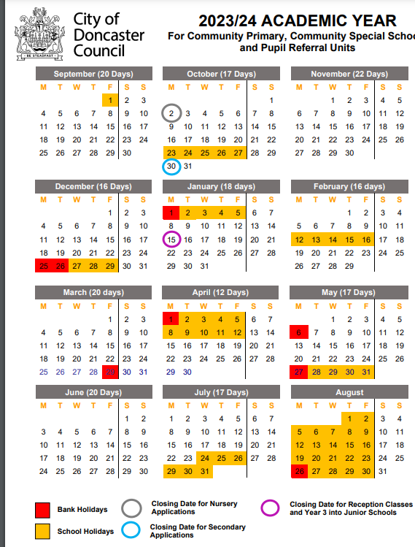

This document should be brought to the attention of and shared with staff, freelance workers, and any volunteers at *Journey Education Group.*

**Journey Education Group**

Published by Journey Education Group © 2024. All rights reserved.

Author | Angela Cousins | Journey Education Group Managing Director

