**Journey Independent School**

**Primary Student Handbook**

**September 2025**



Congratulations **3**

Agreement **4 - 5**

Contents

Congratulations!

Agreements

Alternative Provision: Primary Day

The National Curriculum

Read Write Inc

Reading

Bullying

Journey Calendar

What should I do if...?

Reports and Updates

Student Voice

Safeguarding Information

*Congratulations on joining us here at Journey Independent School!*

Starting a new place of study is an exciting time and an incredible opportunity.

At Journey we aim to ensure that we work with you as an individual to ensure that you have the confidence, courage, skillset, coping mechanisms and outstanding teaching that will enable you to be successful in your next steps.

This new setting is a unique opportunity to ensure that you make quick progress in achieving your goals. It is important that you set these goals high. Think about how we can help you to achieve and try your best everyday. That is all we ask.

Change can sometimes be unsettling. However, at Journey we try to make sure that you get all the information that you need to make this change as easy as possible.

The key to starting well at a new provision is to make sure that you are clear about the expectations that we have of you. Although we have high expectations in terms of your learning, your progress, your attitude towards learning and behaviour and also how you develop your character as you grow up and move towards becoming a young adult, we also work very closely with you to ensure that you have both the opportunity and support to do so.  
  
Make sure that you read the home- school agreement and try your best. It won’t always be smooth going - but we always need to come back to our key rule: Respect.

Finally, enjoy your time here. Those students that get the most out of education are the ones that throw themselves into the experience. There is plenty on offer here.

I am looking forward to meeting you over the next few months and getting to know more about your own aspirations.

Good luck.

Angela Cousins

Journey Independent School

Home/Journey Agreement

Our Aims

* To generate an enthusiasm for learning amongst the students, so that they willingly seek to gain knowledge and understanding about the world around them.
* To provide students with the guidance, information and resources necessary to help them learn and make progress.
* To teach students the skills necessary for effective and efficient learning.
* To provide students with a positive learning environment.
* To develop a sense of pride amongst the students, so that they always aim to achieve the highest possible standards of work in all subjects.
* To foster the personal qualities, skills and self-confidence necessary for success in their chosen career and personal life.
* To develop amongst all students a sense of respect for themselves, other individuals, their own communities as well as others, plus their environment.

As a provision we undertake to:

* Provide a secure, welcoming and high quality learning environment.
* Care for each student’s emotional health and wellbeing.
* Deliver the National Curriculum and provide a broad and balanced education which aims to meet the individual needs of each student.
* Ensure that appropriate home learning is set, marked and monitored.
* Report regularly to parents and provide opportunities to discuss students’ progress.
* To support parents/carers through the period of their child’s transition to Journey Independent School.
* Contact parents/carers if there are concerns about attendance, punctuality, behaviour or progress.
* Respond sensitively and promptly to any concern or complaint raised by a parent/carer or student.
* Provide information and guidance about careers and higher education.
* Acknowledge, celebrate and reward students’ success and progress in all its forms.
* Create opportunities to enrich and enhance student experiences .

Signed (Journey independent School)

___________________________________________________

As a Student of Journey, I undertake to:

* Attend school punctually and with minimum absence.
* Dress appropriately for a school day
* Bring necessary equipment and books
* Complete classwork and home learning as well as I can.
* Ask teachers for help when I have problems with my work and not give up when work is hard.
* Behave responsibly and considerately at all times both in Journey and in the wider community.
* Conduct myself in such a way as to enhance Journey’s reputation.
* React positively to a teacher’s reasonable instructions.
* Seek help from the Journey team if I have a concern or need help or guidance.
* Listen to and act upon advice to develop my academic progress and all other areas of Journey life.
* Observe Journey’s rules and Code of Conduct.
* Engage with any Enrichment Programmes offered by Journey to widen my experiences in life.

Signed (Student)

___________________________________

As Parents and Carers we undertake to:

* To support the aims and ethos of the school while encouraging my/our child
* Ensure that my/our child attends school punctually and with minimum absence.
* Ensure that my/our child is appropriately dressed for a school day.
* Ensure that my/our child completes all home learning set to the best of his/her ability and in reasonable working conditions.
* Attend Parents’ Consultation Evenings and meetings about my/our child’s progress.
* Support my/our child to achieve learning and progress targets by being active learners.
* Support my/our child by reading with them a minimum of three times a week, and recording their progress in their reading journal.
* Not take my/our child out of school during term time without the explicit permission of the centre manager.
* Encourage my/our child to participate in extracurricular activities.
* Recognise and support the rewards and sanction procedures of the school.
* Advise the school of any concerns or problems which might affect my/our child’s progress.
* Work constructively and cooperatively in partnership with the school to resolve any concerns about attendance, punctuality, behaviour or work.

Signed (Parent/Carers)

_____________________________________________

**The Academic Year**

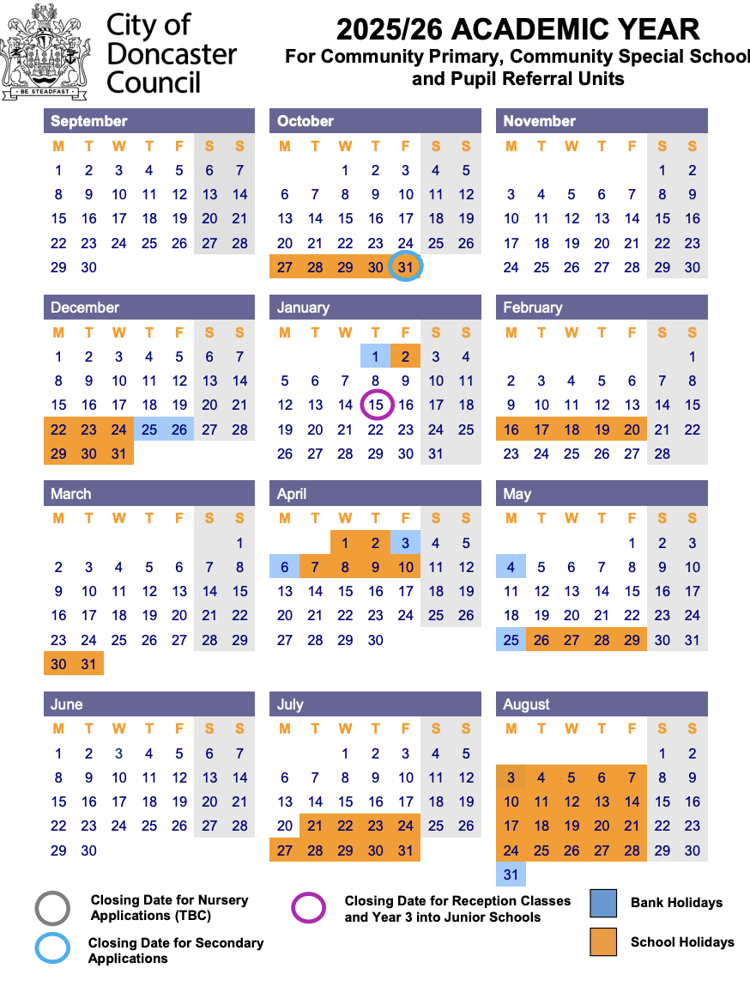

**Primary Day**

| 9:30 – 09:45 | Students arrive, Check in and set goals for the day. Students are supported to prepare for the day, ensure they have eaten breakfast and are ready to learn. |
| --- | --- |
| 09:45 -10:45 | Lesson 1: Literacy/Phonics - Primary pupils attend for different packages - either therapeutic or academic, so the timetable will depend on this.  Our morning sessions enable pupils to develop their core skills through literacy and numeracy lessons, in which unfamiliar concepts are practised and developed through hands-on, malleable activities that promote independence and critical thinking skills. Some of our pupils will have access to Sensory Programmes and Therapy sessions during this time. |
| 10:45 - 11:00 | Morning Break: Students can engage in play on the field or partake in a walk to the forest. |
| 11:00 – 11:30 | Lesson 2: Maths. Students engage in individual maths activities based on White Rose Maths sequencing, following a concrete, pictorial, abstract approach. In maths we focus on the development of key skills such as calculation methods, understanding of place value and decode reasoning problems. We use Times Tables Rockstars to consolidate understanding of multiplication and division in a fun and accessible way and use manipulative resources to support concrete visualisation. |
| 11:30 - 12:00 | Lesson 3: Reading is a fundamental skill that enriches your vocabulary and opens doors to new worlds and ideas. Our goal is to foster a love for reading and improve your reading skills, making reading a rewarding experience. The timetable includes reading for pleasure and guided reading, offering a range of texts and genres to explore and providing opportunities to develop pace, fluency and reading comprehension. |
| 12:00 – 12:30 | Lunch |
| 12:30 - 13:30  13:30 - 14:30 | Lesson 4 and 5 Our afternoon sessions enable pupils to continue their social and emotional development through theme-based learning. We support pupils in their independence through Child Initiated Learning and Role Play. Throughout the sessions, pupils access both indoor and outdoor learning environments. The afternoon session includes opportunities for pupils to access discrete Science, Humanities, Arts,DT, PE, ICT, forest school, dance,music, yoga but to name a few. |
| 14:30pm - 14:45 | Afternoon Break |
| 14:45pm - 15:00 | Reflections on the day where students consider their effort, kindness, attitude to learning and listening across the timetable. Students are supported to identify areas of success and opportunity and set goals for the following day. |

**The National Curriculum**

The National Curriculum provides pupils with an introduction to the essential knowledge that they need to be educated citizens. It also helps engender an appreciation of human creativity and achievement. Journey strives to ensure support pupils to become:

* Successful learners who enjoy learning, make progress and achieve
* Confident individuals who are able to live safe, healthy and fulfilling lives
* Responsible citizens who make a positive contribution to society.

The National Curriculum is just one element in the education of every child. There is time and space in the placement each week to range beyond the National Curriculum specifications. Journey prides itself on the ability to stretch and challenge learners to take them beyond their own barriers and expectations. The National Curriculum provides an outline of core knowledge around which teachers can develop exciting and stimulating lessons to promote the development of pupils’ knowledge, understanding and skills. This is part of a wider curriculum that we use to help grow the learner as a whole person.

**Phonics**

**At Journey, we follow the ‘Read Write Inc’ phonics programme, created by Ruth Miskin.** It is a comprehensive literacy program designed to help students develop strong reading and writing skills.

**What is Read Write Inc (RWI)?**

Read Write Inc is a systematic and phonics-based approach to teaching reading, writing, and spelling. It is built on the following key principles:

* Phonics Focus: RWI places a strong emphasis on phonics, teaching children to decode words by understanding the relationship between sounds (phonemes) and letters (graphemes).
* Structured Learning: The program is structured into well-defined stages, ensuring a gradual and sequential progression in reading and writing skills.
* Assessment and Differentiation: RWI includes regular assessments to monitor each student's progress and tailor instruction to their needs, ensuring that no child is left behind.

**How is Read Write Inc Delivered?**

RWI is delivered through a structured and consistent approach that ensures all students receive high-quality instruction. Here's how it is typically delivered:

* Grouping: Students are grouped according to their reading level and progress, allowing teachers to provide targeted instruction to meet individual needs.
* Daily Lessons: RWI lessons are typically delivered daily, providing consistent exposure to phonics, reading, and writing activities.
* Phonics Sessions: These sessions focus on teaching phonemes, graphemes, and blending skills to help students decode words effectively.
* Reading Sessions: Students engage in guided and independent reading, using books specifically designed to match their current reading level.
* Writing Sessions: Writing activities complement the reading curriculum, allowing students to apply their knowledge of phonics to spelling and writing.
* Assessment and Tracking: Regular assessments and progress tracking ensure that teachers can adjust instruction to meet the needs of each student.

Read Write Inc is a research-based and effective literacy program that focuses on phonics, structured learning, and individualised instruction. By following the principles outlined in this handbook, students can develop strong reading and writing skills, setting them up for success in their academic journey.

**Reading**

Reading is an exciting adventure that opens doors to magical worlds and endless possibilities. In this handbook, we'll explore the wonderful journey of reading, both at school and at home. Let's dive in!

**Why Reading Matters:**

Reading is not just about words on pages; it's about unlocking your imagination, expanding your knowledge, and becoming a confident and skillful reader. The more you read, the more you learn!

**Reading at Journey:**

During your time at Journey, you will have the fantastic opportunity to read with our dedicated adults in our special reading provision. This is a chance to explore books, ask questions, and share stories together. We have hundreds of books in the hub, so there will definitely be something that you can find and enjoy!

**Reading at Home:**

But the reading adventure doesn't end with Journey. We encourage you to read at home too. Reading at home is like adding extra chapters to your reading journey. Here's how it works:

* Minimum Reading Goal: We recommend reading at least three times a week at home. You can read to a family member, a friend, or even to yourself!
* Record Your Reading: Use your reading planner to keep track of your reading adventures. For each time you read at home, jot it down in your planner. This helps you remember your progress.
* Reward Tracker: Every read at home gets you closer to exciting rewards! We have a special reward tracker just for you. Every ten reads earn you a prize. But guess what? When you reach 50 reads, you unlock a fantastic, extra-special reward!

**Tips for Reading Success:**

* Choose Books You Love: Pick books that interest you. Whether it's about space, dinosaurs, or adventures in far-off lands, reading should be fun!
* Read Aloud: Reading aloud is a great way to practice your reading skills and share stories with others.
* Ask Questions: If you're not sure about a word or what's happening in the story, don't be afraid to ask questions. That's how you learn and grow as a reader.
* Explore Different Genres: Try reading different types of books – from fiction and fantasy to nonfiction and comics. You might discover new favourites!

Reading is a fantastic journey, and we're here to support you every step of the way. Reading in the hub and at home, recording your progress, and aiming for those exciting rewards will help you become a superstar reader! So, grab a book, start reading, and let your imagination soar! Happy reading!

**Bullying**

We have zero tolerance for bullying at Journey.

What are the signs and symptoms of bullying? A person may indicate by signs or behaviour that they are being bullied.

Everyone should be aware of these possible signs and should investigate if the person:

– is frightened of walking to or from school or changes route

– doesn’t want to go on public transport to school

– begs to be driven to school

– changes their usual routine

– begins to truant

– becomes withdrawn, anxious, or lacking in confidence

– becomes aggressive, disruptive or unreasonable

– starts stammering

– threatens or attempts suicide

– threatens or attempts to run away

– feels ill in the morning

– asks for money or starts stealing money

– has unexplained cuts or bruises

– is frightened to say what’s wrong

– is afraid to use the internet or mobile phone

– is nervous and jumpy when a cyber message is received

**Reporting bullying at Journey**

You should report bullying immediately if it happens to you or a friend.

How to report bullying

– complete a statement which you can put in the anonymous ideas box

– Tell a member of staff

**Journey Calendar:**

A calendar has been designed by our team in order to keep all individuals in the loop! It will include all important information and events that parents/carers and students need to know including school trips, parents evenings and many more.

**The invite link is below:**

<https://calendar.google.com/calendar/u/3?cid=Y19jYzZmOTc5YWYyODY4ZDdiMzVjY2RkNGNhYWU1NjAxN2NhMjA2NDc1OWQ4NzgxMDYxYWI0NWQ4MTNiN2IxNmFlQGdyb3VwLmNhbGVuZGFyLmdvb2dsZS5jb20>

**What should I do if...**

| I’m running late? | Ask your parent/carer to let us know by calling 01302 492239 |
| --- | --- |
| I am being bullied. | Tell someone – your tutor, a parent, a teacher or a friend. |
| I have a dental/medical appointment? | Ask your parent/carer to let us know by calling 01302 492239 |
| I lost something? | Lost property is kept in the office.  Please leave valuables at home where possible. |
| I don’t understand a home learning task? | See your subject teacher for help. |
| I have forgotten to bring something to school? | Explain to your subject teacher at the start of the lesson. |
| I got something confiscated? | Items will be returned at the end of the learning day. |
| I don’t feel well? | Tell your teacher. |
| I am absent | Get a parent/carer to phone us on 01302796090 |
| I take medication? | Leave all medication at the office. Ask your parent/carer to inform the office and complete a medication form. |

**AP Reports and Parents Evening Dates**

**Term 1 - Autumn**

* 6th November – Autumn Term 1 Progress Report
* 8th January – Autumn Term 2 Progress Report
* 8th January - Parents Evening

**Term 2 - Spring**

* 26th February – Spring Term 1 Progress Report
* 16th April – Spring Term 2 Progress Report
* 16th April - Parents Evening

**Term 3 - Summer**

* 4th June – Summer Term 1 Progress Report
* 9th July - Parents Evening
* 16th July – End of Year Reports

# Student Voice

Student Voice is a huge part of life at Journey Independent School. Students have their own input into decision making at JEG. We want you to explore other positions of responsibility. The skills students get from taking part in Student Voice are important for getting into college, sixth form and University. They show your dedication to your education and development.



**Uniform Policy**

At Journey, we do not have a uniform policy and encourage students to wear clothing that makes them feel comfortable and confident, as we believe this supports their focus and learning. However, we ask that students refrain from wearing pyjamas, as they are not suitable for a school environment. Additionally, we do not permit balaclavas for safety purposes. Regarding jewellery, we allow small studs and watches, but we ask that students leave valuable items at home to minimize the risk of loss or theft. Our goal is to create an environment where students can be relaxed and focused on their education.

**Healthy Eating**

At Journey Independent School we provide a free, healthy hot lunch every day on a 2 week rolling menu to any student in receipt of Free School Meals (FSM). A copy of this can be provided on request, if you would like a copy of this please email admin@journeyeducationgroup.co.uk

For any student not in receipt of FSM, we ask that parents or carers provide an appropriate packed lunch for their child. As we continue to support the growth and development of our students at Journey Independent School, we ask that packed lunches are nutritious and in accordance with the NHS Eatwell Plate guidelines.

<https://www.nhs.uk/live-well/eat-well/food-guidelines-and-food-labels/the-eatwell-guide/>

A balanced diet is essential for our children's physical and mental well-being. It provides them with the energy and nutrients they need to focus, learn, and thrive throughout the day.

Additionally, fizzy, energy, and isotonic drinks are not permitted at Journey Independent School. We believe that providing our students with healthy choices contributes positively to their overall school experience.

# Safeguarding Information

At Journey Education, we are committed to the safety and happiness of our students

Are you feeling unwell or unsafe?

Are you worried about a friend, student or family member?

Does something not feel right?

**Please speak to the**

**Journey Education Child Safeguarding Leads**



Tom or Angela





**Journey Independent School**

Published by Journey Independent School © 2025. All rights reserved.  
Author | Angela Cousins | Journey Independent School Managing Director

